Mississippi Community College Board
Office of Adult Education (OAE)
Narrative Report 2020-2021

- STATE LEADERSHIP FUNDS (AEFLA SECTION 223)
- Describe how the State has used funds made available under Section 223 (State Leadership activities) for each of the following required activities.
- Alignment of adult education and literacy activities with other one-stop required partners to implement the strategies in the Unified or Combined State Plan as described in section 223(a)(1)(A).

Under Mississippi’s Combined Plan, from the instant an individual enters the education and/or workforce system, he or she will be provided the necessary tools to choose and pursue a career pathway relevant to the state’s current and future labor markets.
The Mississippi Community College Board (MCCB), Office of Adult Education (OAE), is the designated agency in the state responsible for administering WIOA of 2014 – Title II. The purpose of adult education in Mississippi is to enable local adult education programs to develop, implement, and improve adult education and literacy services throughout the state to further the vision and goals as outlined in Mississippi’s Combined Plan.
To support the vision and goals of the State Plan, the OAE established the following goals:
- Improve Outcomes by Scaling Effective Models and Strategies across the State:
  - The OAE creates, develops, and expands comprehensive career pathways systems and creating conditions across every adult education program to achieve expansion of evidence-based models.
- Increase Postsecondary Transitions and Credential Attainment
  - The OAE requires each adult education program to have a College and Career Navigator (CCN) in place to provide wrap around services and resources assisting students’ transitioning to postsecondary education or training and earning in-demand credentials that lead to self-sustaining employment.
  - The OAE provided workshops on the importance of engaging employers and One-Stop Centers so they can have more of a direct role when students are making choices in their career planning, for instance apprenticeships, internships, and work-based learning.
- Strengthen College and Career Readiness for Adult Learners
  - The OAE provides training, support, and technical assistance to local programs to prepare adult learners for success in postsecondary education and the workforce. In addition, all adult education programs provide the Smart Start Pathway Course utilizing the framework developed by the U.S. Department of Education: Employability Skills Framework U.S. Department of Education: Employability Skills Framework.
  - In 2019, the Smart Start Pathway Course curriculum was updated to include labor market information and identified sector strategies specific not only to Mississippi, but students learn about the identified sectors for their specific workforce area.
  - The Mississippi Department of Education (MDE) requires all high school graduates beginning with the Class of 2022 to pass a specifically designed College and Career Readiness (CCR) course. Since the goals of the CCR course are very similar to those of the Smart Start Pathway Course, MDE approved the Smart Start Pathway Course to serve as a dual credit substitution satisfying the CCR high school graduation requirement (https://www.mdek12.org/ese/College-and-Career-Readiness).
- Develop Multi-Level Career Pathways Options
  - The OAE, through various workshops and training, equipped local programs to design multiple entry points into postsecondary education for various functioning levels of adult education learners. Each entry point is aligned to clearly identify student readiness levels and credentials, certifications, and/or degrees leading to employment in high-growth, family-supporting jobs. The following model was used at a spring 2020 training to local education program directors, workforce development directors, career-technical directors, and other workforce and community partners.
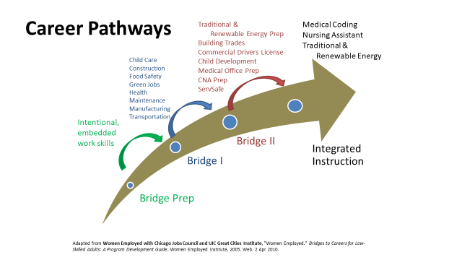

- MIBEST – Mississippi’s Integrated and Basic Education Training program transitioned to the OAE in March 2019. The program teaches students academic, workforce, and college-readiness skills in a fast-paced, supportive environment. Through a combined teaching model, students are able to work on college-level studies while also preparing for their high school equivalency diploma. MIBEST is valuable to Mississippi’s workforce needs since students are exiting the program with employability skills and occupational credentials deemed necessary by employers for successful transition and retention to employment. Mississippi’s 15 community colleges have MIBEST representatives along with the CCN who assist with enrollment, career exploration, and transition resources. During PY 20, IET pathways were expanded to all students regardless of their educational functioning level.
- Establishment or operation of a high-quality professional development programs as described in section 223(a)(1)(B).

The primary goal of the OAE’s use of state leadership funds is to provide high quality and ongoing professional development to ensure adult education practitioners are able to implement the requirements and intention of the WIOA. The OAE works to ensure professional development program(s) at the state and local levels align with the goals of the state and local workforce development plans to meet the needs of workers and employers. Adult educators are trained to utilize evidence-based best practices in instruction enabling every adult learner in Mississippi to acquire the necessary basic skills to compete successfully in today’s workforce.
To ensure the instructional effectiveness of new teachers, the state requires all new instructors to participate in the New Teacher Academy (NTA). This Academy is offered at the beginning of the fiscal year and offers an overview of the Mississippi Adult Education system, our policies, instructional methodology for adult learners, and program design. Each new teacher is matched with a mentor teacher from their local program for the first year. This mentor is available to help the new teacher as he or she navigates through his or her first year in adult education. Ongoing professional development is provided for these individuals throughout their first year. This year the NTA Academy was provided virtually using the Canvas platform. Teachers participated in synchronous and asynchronous activities.
The OAE developed an online course with multiple modules called Back 2 Basics for local program use to provide consistent training on guidelines throughout the state. This interactive course has been updated to provide all adult education staff the knowledge of the policies and guidelines for the state. The course has embedded assessments to ensure the transfer of information. Modules included are as follows:

- Program Overview: AEFLA & WIOA
- Intake and Orientation
- Program Accountability & National Reporting System
- Mississippi Assessment Policy & TABE
- TABE CLAS-E
- Retention and Persistence
- Transition Services
- Professional Development

The state’s professional development system includes training in reading instruction which incorporates the essential components of reading.
- STudent Achievement in Reading (STAR) training. This year’s cohort consisted of nine directors and seventeen instructors. The cohort participated in the online coursework from October 2020 to May 2021. Two days of live training were conducted using the Zoom platform. One teacher changed jobs mid-year and was unable to finish the course. Sixteen instructors finished the course and were awarded certificates and stipends. A STAR Resources Canvas Course was developed to provide these instructors with diagnostic materials to use for remote testing.
- Reading Horizons. No training was provided this year for Reading Horizons; however, technical assistance requested was provided to programs using the software.
- CommonLit. Due to the Covid-19 pandemic, the OAE sought ways to help instructors provide high-quality, research-based reading instruction in a distance learning format. CommonLit’s reading program has been optimized for computers and mobile devices. When using CommonLit on a mobile device, adult learners can log in, read passages, answer comprehension questions, and track their own progress. Teachers have free access to all the materials and the management system. CommonLit’s resources are flexible, research-based, created by teachers, for teachers, and aligned to the Common Core State Standards. The state entered into a project with four of our local programs and CommonLit to pilot their new digital curriculum. All instructors in the state have access to CommonLit’s online resources and units, but these four programs have access to the new CommonLit curriculum. CommonLit provided training for all instructors in the state and a separate training for the pilot group.
- Jumpstart. The state partnered with Jumpstart to provide instructors with seats for Math instruction in a pilot project. Jumpstart utilizes videos of math instruction by experts to help students of all ability levels stay fully engaged and gain the most improvement in the shortest time by explaining difficult content in a way every student can follow and understand. Students and teachers were provided seats for Jumpstart along with a workbook for study.
- Northstar Digital Literacy. Digital Literacy skills are of vital importance for adult learners in competing in today’s workforce. The OAE has provided adult educators training in how to teach digital literacy skills and integrate those skills into content instruction. Northstar Digital Literacy Skills was purchased as a state license. Each program has access to this resource for use with students. The resource provides self-guided assessments to measure mastery of basic skills in 14 areas. Test takers can receive certificates and/or digital badges when they pass a Northstar assessment in a proctored environment at a Northstar testing location. Classroom curricula provides detailed lesson plans for teachers and can be used remotely or in person. Northstar Online Learning provides individualized online instruction and practice.
The OAE’s professional development activities have changed to support instructors and other service providers during the Covid-19 pandemic. In PY 20, over 175 hours of professional development were provided for statewide adult education programs and community partners in various topics reaching approximately 300 individuals. All professional development was offered via Zoom meetings and webinars. This was an easy transition for the state because we had already been conducting monthly Wednesday Webinars.

A Canvas course called Skill UP Webinar Course was designed to house all recorded webinars. This allowed instructors and program staff to access the training at any time. Digital surveys and certificates were developed for all webinars to provide immediate training evaluation and records of professional development hours for staff. Canvas courses were developed for the New Teacher Academy and New Director Academy to provide a hybrid approach for synchronous and asynchronous learning. Professional Development specialists in the state developed a plan to provide training on learning management systems (Canvas and Google Classroom), a How-to Guide for teaching online, and an HSE online Canvas course. The assessment policy was amended to allow for remote testing. Webinars to train adult education staff were conducted to provide an effective transition from face-to-face testing to remote testing. All Wednesday Webinars were changed to address how to teach content remotely.
The Articulate files for the Transforming Distance Education Course developed by the EdTech Center at World Education were received and a Canvas Course was developed to provide instructors with a certificate and CEUs upon completion of the course.
TABE CLAS-E Assessment training was developed into a Canvas Course for new CLAS-E administrators. A Recertification course was developed for existing administrators to become recertified every three years.
An Adult Education Online Teaching Resources Guide was developed and state staff provided an Unpacking the Resource Guide webinar to assist instructors and program directors in developing effective online instruction.
This year’s summer conference was provided virtually using the Canvas platform. It was a conference to celebrate our state instructors for all the hard work done during the pandemic. Instructors shared innovative practices used during the pandemic.
Specific areas of professional development for this year include:

- Data Management Training (LACES)
- Using Data for Program Improvement
- Annual New Teacher Academy
- Annual ELL Training Institute
- TABE 11/12 and TABE CLAS-E
- Workforce Essential Training – Smart Start
- Using data for program improvement
- Northstar Digital Literacy Training (series)
- Back to Basics Online Course
- Canvas Training (series)
- Directors Training
- Teaching Using Blended/Virtual Models
- Career Transitions
- Career Pathways Training
- Curriculum for Adult Literacy (Math)
- Transforming Distance Education
- Trauma Training (series)
- IET and Single Set of Learning Objective
- Using Career Pathways to Contextualize Instruction for Adult Learners

All professional development activities were evaluated using a google form linked to a PD hours of completion certificate. After each webinar or training event, teachers were given a link to complete a survey/evaluation of the activity. These results are used to guide the professional development staff when providing technical assistance and training to improve adult education activities.
- Provision of technical assistance to funded eligible providers as described in section 223(a)(1)(C).
Ongoing technical assistance is provided to local programs to enhance program effectiveness. State staff paid with State Leadership funds provide technical assistance in the areas of remote assessment (TABE 11/12 and TABE CLAS-E), data management for program improvement, and English as a Second Language. Data management and online instructional formats for program improvement were areas of technical assistance this year.
Technical assistance was provided via Zoom as well as face-to-face upon request to programs which were on the Program Improvement Plan.
WIOA and the National Reporting System (NRS) frame accountability in adult education in Mississippi. State Leadership funds are used to enhance the web-based data collection/management system used by all federally funded adult education programs. The following are activities and initiatives used to connect assessment and accountability in Mississippi as referenced in the State Plan for Title II of WIOA.
- Mississippi is committed to reaching the individuals who are basic skills deficient by targeting federal funds to students working below an 8.9 grade level equivalent. During the fiscal year, just over 97% of the total students served were adults with low levels of literacy and/or in need of English Language Acquisition: 92% of the students served were ABE level students and 5% of the students served were English Language Acquisition (ELA) (NRS Table 4).
- MS OAE’s monitoring procedures included analysis of data and program performance through monthly data submissions and desk reviews. Follow-up onsite visits were conducted when warranted.
- During 2020-2021, Mississippi’s onsite monitoring instrument incorporated five vital modules – WIOA and State Plan Coordination, data quality, curriculum, instruction, and finance. Four programs were selected for monitoring in PY 20. Virtual monitoring and classroom observations were conducted through a Canvas course and Zoom meetings. Programs being monitored would upload all required documents. Monitoring reports were prepared after each monitoring visit. Sites that were non-compliant or had findings received recommendations for program improvements. Programs were given 30 days to prepare and submit a written plan of action describing the plan of resolution. State staff were assigned to ensure all plans were adhered to and non-compliance addressed in a detailed follow-up process to ensure a resolution was determined and put into effect.
- Technical assistance was ongoing to all programs, with a focus on and follow-up given to sites with indicated findings and low performance outcomes.
- MS OAE continued to utilize established techniques for providing technical assistance to programs. The procedures included: performance target requirements and continued data review. A uniform Desktop Monitoring Tool was designed to assist programs in tracking their progress in meeting the benchmarks and standards. Providers continued to be ranked in the state by benchmarks and pre-post testing. This system was put in place to help both the OAE and program staff identify program strengths, areas for improvement, technical assistance, and professional development needs.

- Monitoring and evaluation of the quality and improvement of adult education activities as described in section 223(a)(1)(D).
Monitoring and evaluations are accomplished by multiple methods. Desktop monitoring and actual on-site review visits make up the process used to evaluate the success and/or areas for program improvement. The OAE utilizes a Desktop Monitoring Tool based on the National Reporting System (NRS) Educational Functioning Levels (EFL), Measurable Skill Gains (MSG), High School Equivalency attainment, and postsecondary education, training. Mississippi included four additional state indicators to include: 1) Posttest-rate goal, 2) Smart Start Credential attainment, 3) National Career Readiness Certificate attainment, and 4) Career Pathway enrollment.
After the completion of the desk audit, programs are contacted by phone, email, or a visit to discuss recommendations for improvement and to provide technical assistance. Programs are required to follow-up on how to increase performance in those areas. The state continues to revise and adapt new features to the compliance review and technical assistance process. Desktop monitoring is completed for all programs quarterly, at a minimum, to assist programs with staying on track and meeting the annual state performance target.
When completing formal on-site / virtual holistic program monitoring, if it is determined a program is in noncompliance with state and federal policies related to local data management and program services, the program is placed on a Corrective Action Plan. In addition to these formal monitoring and evaluation methods, review of dashboard data and other data analysis frequently prompts targeted technical assistance of specific performance areas, which generally includes a deeper assessment/evaluation of the area being analyzed. Programs who do not meet the annual state performance target are required to complete the Desktop Monitoring Tool (see below) monthly, in lieu of a Performance Improvement Plan in response to continued COVID restrictions, as well as receive intensive technical assistance.

Mississippi AE Desktop Monitoring Tool:
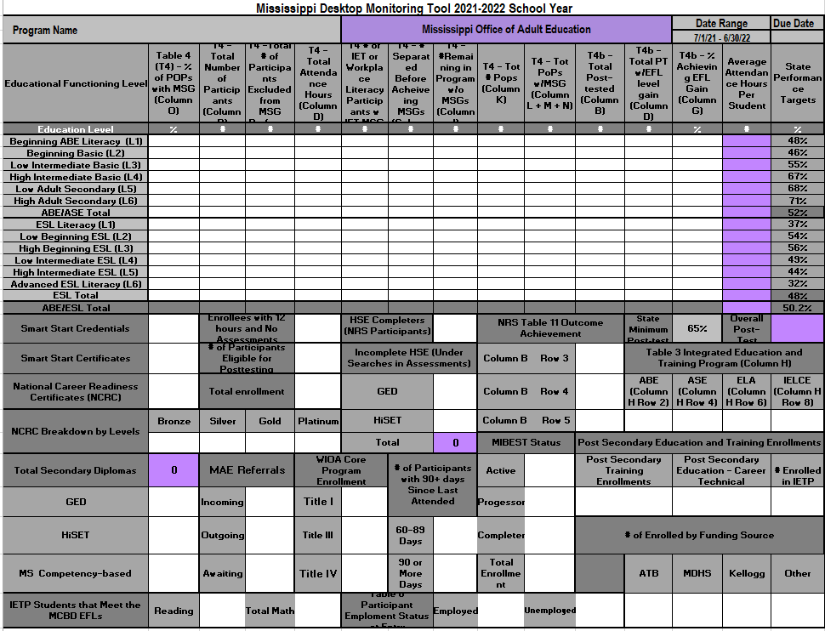
On-site monitoring visits are formal, scheduled visits with local program providers and are on a three-year rotation cycle. These visits consist of examining the progress made in the project against the agreed upon goals set forth in the application for funds. Monitoring visits also provide an opportunity to make constructive suggestions, recommendations, learn best practices, and note areas in need of specific professional development. Monitoring also employs systematic collection of data and on-site observations to provide stakeholders the extent of progress and achievement of objectives, proper and lawful use of funds, and compliance with federal and state policies and guidelines. On-site review visits were impacted by the pandemic and had to be postponed at the start of FY 21. The OAE began implementing Virtual Monitoring in January 2021. Programs were required to upload documents into our Virtual Monitoring Canvas Course for OAE staff members to review prior to the visit. This change shortened the average monitoring visit length from four to five days to one to two days, minimizing disruptions to local programs. The addition of the Student Panel Discussion during the virtual monitoring process has also provided much-needed student feedback and an opportunity to interact with the participants. An Official Follow-up Letter is provided within 30 days of the virtual monitoring interview. Programs also receive immediate, high-level, verbal feedback during the interview. MS OAE plans to update the monitoring process and streamline documents into a monitoring manual which includes a risk assessment. Risk assessments are conducted annually to determine which programs to monitor.

- As applicable, describe how the State has used funds for additional permissible activities described in section 223(a)(2)
To meet the diverse needs of our students as well as part-time adult education programs, the Smart Start Pathway Course was created in the on-line format, Canvas, in the spring of 2019. To be able to allow students the flexibility of a hybrid or completely online atmosphere with the same high-quality learning experience, was a priority of the OAE. With the assistance of MCCB’s eLearning and Instructional Technology department as well as the OAE’s Smart Start state curriculum team, the ability to add, build, or modify digital content to enhance the student’s learning experience is quickly accomplished.

In 2018, the OAE started an initiative called Skill Up Mississippi with the full purpose to transform the mindset of adult education. Adult education is no longer just about high school equivalency preparation. Our programs focus on much broader, higher-level skills students need in order to transition into further education and/or training or the workforce. Along with high school equivalency preparation, programs also offer the Smart Start Pathway Course, English as a Second Language classes, and Mississippi’s Integrated Education and Basic Skills Training (MIBEST).

In order to strengthen the message of how adult education programs are “skilling up” students, the OAE created the website, www.skillupmississippi.com. An array of information, such as community partners; an interactive map of all adult education programs; various program offerings; resources for employers; and student success stories are evidence of the OAE’s efforts to communicate adult education in Mississippi is helping individuals enhance their skills while strengthening the state’s workforce and economic development needs. During PY 20, pages were added to the website for English Language Learners, eDULT Online, and AE On Demand. AE On Demand has our podcast and video recordings of interviews with program directors, College and Career Navigators, and state staff.

In January 2021, the Office of Adult Education in Mississippi was able to hire an Instructional Specialist whose primary role is to create – through research and forming partnerships – a robust Online HSE program. The program is titled, eDULT Online. The course was built in Canvas – a popular Learning Management System (LMS). The first pilot launched in July 2021.

The state’s College and Career Readiness Standard’s (CCRS) Team (team of 7 instructors and 2 state staff) helped the new Instructional Specialist at the Office of Adult Education begin development of the eDULT Online.
Content courses were developed at three levels: 100, 200, and 300. Each subject, math, science, social studies, and reading language arts has its own unique course but follows a standard framework and outline over the course of seven weeks. One of the program’s key features is the eSkills Success Series Course and learner portfolio. This course serves as an orientation to becoming an online student, and additionally provides various opportunities for students to build soft skills and aids in the development of community and continuity throughout the program. Students will have the opportunity to interact with peers, coaches, and instructors in various synchronous and asynchronous formats while attaining their educational, personal, and professional goals through participation in eDULT.

- PERFORMANCE DATA ANALYSIS
  - Describe how the adult education program performed in the overall assessment of core programs based on the core indicators of performance. Discuss how the assessment was used to improve quality and effectiveness of the funded eligible providers and any plans to further increase performance in future reporting years.
Mississippi served 10,043 (NRS Table 2A + Table 4) undereducated and underemployed citizens in FY 2020-2021 with 5,497 students participating in basic skill instruction (NRS Tables 4). Mississippi achieved a Performance Rate (MSG) of 53.3% for program year 2020-21, slightly lower than the required MSG target of 49.3% (NRS Table 4). Effective instruction at the local level is evident by the fact that 70.14% of students who post-tested (NRS Table 4B) demonstrated an EFL gain.
Examination of the 2010-21 Federal Tables showed overall program participation continued to decrease significantly, 7,014 to 5,497 (NRS Table4 for FYs 20/21), a decline of about 22%. Attendance hours decreased about 28%, while distance-learning hours also continued to decreased by 47% (1095) in FY21 due to a gradual return to face-to-face instruction. The downward enrollment trend is not projected to increase as we are still managing the fallout from COVID-19.
Mississippi OAE works with the National Strategic Planning and Analysis Research Center (NSPARC) to data match for the primary indicators of performance on Table 5. Results for PY 2020-2021participants show: 48.17% were employed second quarter after exit; 47.86% were employed fourth quarter after exit; the median earnings second quarter after exit is $2,944.00; 36.36% attained a secondary school diploma/equivalent and enrolled in postsecondary education or training within one year of exit; 34.19% attained a secondary school diploma/equivalent and were employed within one year of exit; 45.11% attained a postsecondary credential while enrolled or within one year of exit; and 46.11% attained any credential (unduplicated).
Mississippi has 82 counties in the state with 19 fiscal agents providing services in each county. These 19 providers account for over 300 classes and 336 staff. Part-time staff (less than 19 hours a week) makeup approximately 30%% of the total staff. During the 2020-21 program year, there were 36 staff with less than one year of experience (Table 7).
Mississippi, like most of the nation, suffered the effects of COVID-19 toward the latter end of the fiscal year, thus resulting in the inconsistency of local program performance. Navigating program closures, lack of technology, limited virtual teaching skills and resources, social distancing requirements, lack of online assessment options, and overcoming barriers such as transportation issues, participant attendance decreases due to assisting their own children with virtual learning or simply the fear of exposure created lower than normal EFL completions. Many of our programs’ enrollment were cut in half compared to FY19. Our Corrections programs have yet to recover.
To continue the trend of performance achievement, local programs were provided target percentages for each educational functioning level (EFL) on a monthly basis through the utilization of the Desktop Monitoring Tool. Technical assistance has become strategically focused on ways to earn an MSG, components of the NRS data tables, and ways to improve performance. We encourage the use of the OAE-developed Instructor Class Monitoring Tool which allows programs to disaggregate data at the classroom, instructor, and student level in order for local programs to compare their performance to the benchmarks and identify which staff members need additional support.
Important state data which is not reflected in the NRS data is the number of work ready certifications earned through adult education. Two of the state recognized certifications in Mississippi are the National Career Readiness Certification (NCRC) and the Smart Start certificate which aligns with our State WIOA Plan. The number of National Career Readiness Certifications (NCRC) for FY 20-21, based on the ACT Work Keys assessments, was 2,735. Also, the state awarded over 1,890 Smart Start certificates to adult education students supporting the State’s mission of producing individuals with the necessary skills needed to be successful in the workplace as well as life. In addition, participants maintained employment after exit for both quarters at a rate of approximately 47%.
MS OAE plans to continue to develop reports, trainings, and resources which support local programs’ abilities to analyze performance in real-time and use data to drive instruction and improvement.

- INTEGRATION WITH ONE-STOP PARTNERS
  - Describe how the State eligible agency, as the entity responsible for meeting one-stop requirements under 34 CFR part 463, subpart J, carries out or delegates its required one-stop roles to eligible providers. Describe the applicable career services that are provided in the one-stop system. Describe how infrastructure costs are supported through the local option. In the event the local option was not used in a local area, indicate that the State option was triggered.

Mississippi developed a career pathway model, Mississippi Works Smart Start Career Pathway Model, to outline specific steps and responsibilities with and between Combined Plan Core Partners in order to strengthen interagency partnerships. All Combined Plan Core Partners created and agreed upon a diagnostic questionnaire to assist with identifying eligible services in each core partner program and to provide wrap around resources addressing the individual’s barriers to employment/education. Based on an individual’s responses to the diagnostic questionnaire, services and resources are referred through an electronic referral process, the MS WIOA Hub. Data in the hub, illustrated below, is exchanged between core partners ensuring all agencies are coordinated not only for the purpose of reporting and performance but also in the partner’s approach to individual case management.

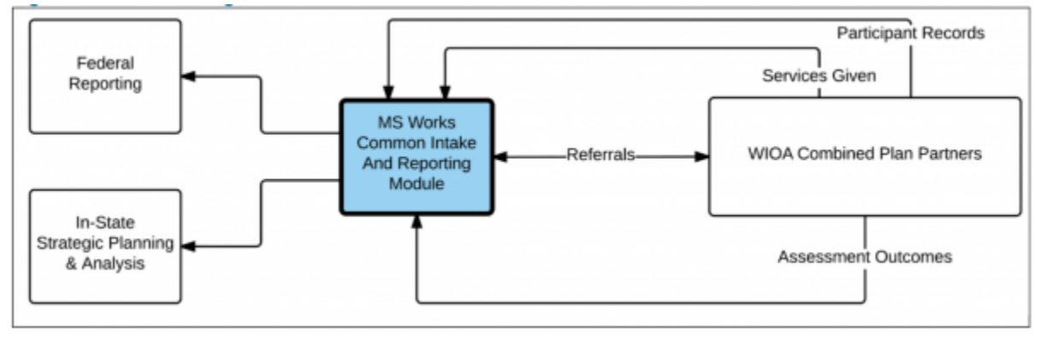

The OAE has aligned adult education and literacy activities with other core programs and one-stop partners as outlined in the State plan. A requirement of all OAE local programs’ core services is to provide the state’s workforce preparation course, Smart Start Pathway Course. The 45-hour course includes instruction and activities designed to assist an individual acquire a combination of academic, critical thinking, digital literacy, and workplace discipline in order for them to successfully transition into postsecondary education and/or training or employment. It is through Smart Start, individuals learn about the different workforce areas, job sector strategies, and economic development specific to MS workforce needs. All individuals are registered in the MS Works Labor Exchange and through created profiles utilize the system to research occupations and become more aware of Mississippi career pathways.

To strengthen interagency partnerships, adult education provides a cross-trained adult education representative in the four (4) Comprehensive One-Stops (American Job Centers) as well as in several Affiliate One Stops throughout the state. Adult education assists programs with the coordination and delivery of key services within the one-stops and affiliate one stops delivery system, such as instruction, workshops, assessments, ACT WorkKeys Curriculum, ACT WorkKeys testing, Individual Training Accounts, and referral services.

In partnership with Comprehensive One-Stop and Affiliate One-Stop centers, adult education remains up-to-date of changing industry needs and measures the outcomes to realize the potential of the state’s workforce programs and delivery systems while participating in system-wide efforts to increase awareness of the Mississippi workforce system among employers and job seekers.

Adult education providers, along with other workforce area service providers, align available resources in order to achieve the strategic vision and goals of the Mississippi Works Smart Start Career Pathway Model. Participants in need of the most intensive services to become job ready are referred to adult education’s Smart Start Program. Upon completion of Smart Start and other educational/career goals, participants will transition into a career-technical educational and/or workforce training or directly into unsubsidized employment, often with assistance from the coordinating One-Stop Center.
Mississippi’s vision of cooperation between workforce stakeholders is to ensure all state resources would be marshalled to improve workforce participation, meet recruitment needs of business and industry, and connect job seekers in real time with resources necessary for success.
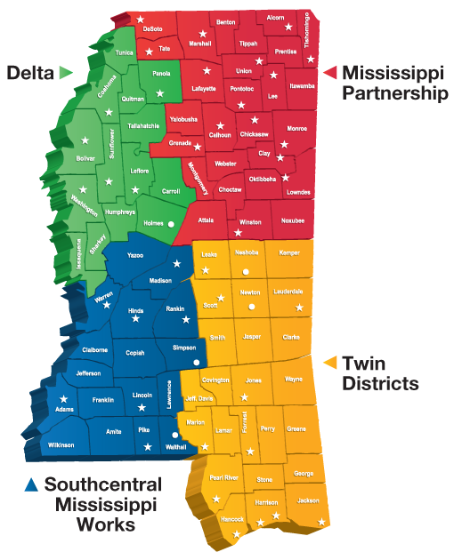
Mississippi has four (4) Local Workforce Development Areas (LWDAs) that house at least one Comprehensive One-Stop Center and several Affiliate One-Stop Centers. Comprehensive One-Stop Centers staff a member from each of the WIOA Combined Plan Partners, who can provide fully assisted services to all participants, whether it’s registering in Mississippi Works Labor Exchange; providing knowledge about individual programs; assisting with virtual, self-service access to workforce and employment resources; or providing access to education and training opportunities. Additional services are provided if determined appropriate for the participant, such as individualized career planning and counseling; internships and work experience; workforce preparation activities; adult education and literacy activities; financial literacy training; and English language classes.

Unlike the Comprehensive One-Stop Centers, Affiliate One-Stop Centers do not require a staff representative from all of the WIOA Combined Plan Partners; however, the Affiliate must include at least two Combined Plan Partner Programs, which for a majority, an adult education program is on-site.
Delta Region
Training services are available through the One-Stop Centers in the Delta area, one in particular specialized training, such as electrical utility lineman training. Mississippi Delta Community College (MDCC) adult participants are eligible to enroll in the electrical utility lineman training while working on their high school equivalency at the same time. MDCC has adult education classes in the One-Stop Center as well as promotes opportunities for education and training through initiatives such as the W.K. Kellogg Foundation’s financial assistance for low-income and working families.
Mississippi Partnership
Northwest Mississippi Community College (NWCC) serves as the One-Stop Career Center Operator and provider of career and training services. The center offers job search, job placement, labor market information, educational and career counseling, financial assistance for training, high school equivalency preparation classes, internships and work readiness, job readiness course, Smart Start, and Gateway Out-of-School Youth Program. Both NWCC’s adult education director and IET navigator assist with job fairs, adult and education trainings, and provide professional development.
Twin Districts Region
Through the relationship with the LWDA and the One-Stop Center, adult education is aligning services, curriculum, and certificates/credentials deemed necessary toward one of the LWDA’s unique and specific industry demands, for instance shipbuilding. Pascagoula Adult Learning Center (PALC) created a 6 week (64-96 hours) pre-apprenticeship program, where students are working in adult education literacy activities and attending shipfitting workforce classes at night. Upon completion, the students enroll in a 6 week on-the-job-training program at Ingalls Shipbuilding with the intent of getting hired with a starting pay of $16.02. The adult education director of PALC attends the LWDA’s quarterly meetings to provide information or updates with the various training opportunities for those who need to enhance their skills in order to enter or re-enter the workforce.
Southcentral Mississippi Works Region
Hinds Community College’s Adult Education program, overseeing the WIOA program in three (3) local One-Stop Centers, provides employment training for adults, dislocated workers, and youth. The One-Stop Center provides federal aid to support an Individual Training Account (I.T.A.) to qualifying adult education students attending approved Career-Technical Programs at Hinds Community College. Programs such as Banking and Finance; Diesel Equipment; Industrial Maintenance; Computer Network; Healthcare Data; and many others can be found on the One-Stop Center’s website at https://etpl.mdes.ms.gov/FrmSearchHome.aspx.

- INTEGRATED ENGLISH LITERACY AND CIVICS EDUCATION (IELCE) PROGRAM (AEFLA SECTION 243)
- Describe how the state is using funds under Section 243 to support the following activities under the IELCE program:
    - Describe when your State held a competition [the latest competition] for IELCE program funds and the number of grants awarded by your State to support IELCE programs.

The OAE held a competition for IELCE funds in combination with the competition for AEFLA funds using the same Request for Application. We received two applications for Section 243 funds for MS Gulf Coast Community College and Hinds Community College which both received AEFLA Funding for the operation of Adult Education Programs and also received multi-year grants for Section 243 funds.

    - Describe your State efforts in meeting the requirement to provide IELCE services in combination with integrated education and training activities:

Integrated English Literacy and Civics Education includes instruction on the rights and responsibilities of citizenship and civic participation, and may include workforce training (Section 231 funds). These funds are used in combination with Integrated Education and Training (Section 243 funds).
Programs meet the requirement to use funds for integrated English literacy and civics education in combination WITH integrated education and training activities by either:
- co-enrolling participants in integrated education and training, as described in 34 CFR Subpart, provided within the local or regional workforce development area from sources other than Title II Section 243
- using funds provided under Title II Section 243 to support integrated education and training activities as described in 34 CFR Subpart D

During PY 20, training was provided to all ESL teachers in regards to Section 243. During intake, all ESL students were introduced to their College and Career Navigator and received detailed information on the IET programs available at their respective locations. Students were given the opportunity to tour IET programs to get a feel for the skills they would learn and a better understanding of the specific job sector aligned to those skills as well as the beginning rate of pay. Push cards were developed in Spanish, which is the main language for our ESL students, to promote the services offered. Students at Hinds Community College participated in field trips to the Museum of Mississippi History, Mississippi Civil Rights Museum and the state capital to enhance civil education instruction. For the upcoming program year, students will be exposed to local business and industry by inviting those leaders to speak or field trips to the facilities.

    - Describe how the State is progressing towards program goals of preparing and placing IELCE program participants in unsubsidized employment in in-demand industries and occupations that lead to economic self-sufficiency as described in section 243(c)(1) and discuss any performance results, challenges, and lessons learned from implementing those program goals.

Students are enrolled in the Smart Start Course where they receive instruction on basic skills and workforce preparation. The 45-hour course includes instruction and activities designed to assist an individual acquire a combination of academic, critical thinking, digital literacy, and workplace discipline in order for them to successfully transition into postsecondary education and/or training or employment. It is through Smart Start, individuals learn about the different workforce areas, job sector strategies, and economic development specific to MS workforce needs. All individuals are registered in the MS Works Labor Exchange and through created profiles utilize the system to research occupations and become more aware of Mississippi career pathways.

These students also work closely with a College and Career Navigator (CCN). The role of the CCN has proven to increase student retention and goal attainment for students enrolled adult education as well as students enrolled in an IELCE program. All adult education programs are required to employ at least one (1) CCN; however, because this position provides intensive, individual, on-going case management, larger programs or sites with multiple campuses, may need to increase the number of navigators to ensure all students receive the guidance and support to be successful in the program. The CCN also provides on-demand assistance to mitigate barriers as they arise to ensure students have access to support services and are able to continue in their program of study.

    - Describe how the State is progressing towards program goals of ensuring that IELCE program activities are integrated with the local workforce development system and its functions as described in section 243(c)(2) and discuss any performance results, challenges, and lessons learned from implementing those program goals

In addition, the navigator and the program director work with CORE Partners to refer and place students in jobs related to their field of study. In collaboration with the State Workforce Investment Board and the Local Workforce Development Boards, we have expanded opportunities for Work-Based Learning, Internships and Apprenticeships.
COVID has affected the ability to partner with many of our business and industry in the state due to limited access to plant facilities. It is our vision to expand these opportunities in the upcoming year.
- ADULT EDUCATION STANDARDS
  - If your State has adopted new challenging K-12 standards under title I of the Elementary and Secondary Education Act of 1965, as amended, describe how your Adult Education content standards are aligned with those K-12 standards.
Previously in 2019, to fully align to the Mississippi K-12 Common Core standards, the OAE created a statewide CCRS Implementation Team consisting of adult education instructors, local program directors and state staff who participated in CCRS Standards-in-Action Training led by LINCS Trainers on how to implement standards in Mississippi. To ensure the sustainability of standards-based instruction throughout the state, the OAE had established a train-the-trainer model. Due to restrictions from the pandemic, the CCRS team inevitably had to pivot and adjust from the original course of action.

Pre-Covid, there were ambitions to develop an online high school equivalency course to mitigate barriers that were prohibiting adult learners across the state from earning their high school diploma. The Office of Adult Education sought funding to create a position to spearhead the initiative which was a perfect solution when Covid hit, reaffirming the need for the program to be developed. The instructional specialist brought on to develop and design the program was aided by the CCRS team.

Course blueprints were researched and designed based on the CCRS and TABE 11/12 blueprints by the instructional specialist in conjunction with the CCRS team. Following the course outlines, content was developed for the 300 level courses in all major subjects – reading language arts, mathematics, science, and social studies. Instructors from the CCRS team were then trained to facilitate courses for the pilot of eDULT Online which had its scheduled launch in July 2021.

Additionally, negotiations began for the development of two CCRS foundations courses to be a focal point for adult education professional development in 2022. The two courses, one for English Language Arts and one for Mathematics, will be housed within the Canvas LMS and will be the cornerstones for refreshing instructional practices professional development in the next program year.

- PROGRAMS FOR CORRECTIONS EDUCATION AND THE EDUCATION OF OTHER INSTITUTIONALIZED INDIVIDUALS (AEFLA SECTION 225)
  - What was the relative rate of recidivism for criminal offenders served? Please describe the methods and factors used in calculating the rate for this reporting period.

The Office of Adult Education (OAE) relies on the MS Department of Corrections to provide the recidivism rate and the process for determination. The state’s current recidivism rate is 35.4%. MDOC tracks recidivism based on the number of inmates returning with a 3-year period. The majority of probationers were African-Americans at 51.99% (13,497) compared to Caucasians at 46.37% (12,037). African-Americans comprised the majority of parolees at 53.72% (5,032) compared to Caucasians at 45.38% (4,251). As of December 17th, there were 459 inmates having less than 180 days until flat-time; another 2,851 are candidates for discretionary release through parole and earned release supervision (ERS). This information is for all offenders in the state, and is not a representative for only those served in adult education.

Adult Education services are provided to offenders at the three state facilities: Parchman, Central MS Correctional Facility, and South MS Correctional Institution. In addition to these facilities, local programs provide adult education services in seven county/regional correctional facilities. An offender is any individual who is charged with or convicted of any criminal offence.

