2017-18 Narrative Report
1. State Leadership Funds
The Adult Education and Family Literacy Act (AEFLA) State Leadership funding supports the work of the Workforce Innovation and Opportunity Act (WIOA) and is under the direction of the State Director of Adult Education and the state WIOA Leadership Team. Members of this team include senior leadership from core WIOA programs. The WIOA Leadership Team has continuously met throughout the implementation of WIOA to coordinate the transition to WIOA reporting standards, as well as hosting collaborative learning opportunities for staff working within our state plan partner programs. The WIOA Leadership Team also monitors and directs the work of specific WIOA sub-committees. Furthermore, during the 2017-18 fiscal year, the WIOA Leadership Team also organized several cross-agency field research convenings that included AEFLA-funded programs.
Regarding WTCS AEFLA Leadership funding, during the program year the WTCS provided support for eligible adult education and workforce providers to learn about their potential role as one-stop partners in a variety of ways that includes:
- Systemwide meetings and numerous webinars/teleconferences open to all AEFLA grantees for the purpose of discussing a variety of topics, including promising practices for transitioning ABE learners into the workforce and/or into postsecondary occupational instruction.
- Final regional meetings and statewide webinars regarding elements and requirements related to the state’s AEFLA open competition for funding. During the previous year AEFLA Leadership funding supported the provision of five AEFLA Forums across the state; these forums allowed WTCS staff to share information about becoming an AEFLA eligible provider. Questions were collected at each forum, and responses were put into a Q&A that was posted on the WTC System website.
- The cross-agency Common Ground Conference in 2017.
- Gatherings for WIOA partners from all 11 Workforce Development Areas at the previously mentioned Common Ground conference.
- Support for Title II grant application review teams consisting of WIOA partner agency and out-of-state AEFLA leaders.
The provision of high-quality professional learning is a cornerstone of Wisconsin’s ABE programs at the state and local levels. During the 17-18 year, WTCS used state leadership funds (including non-AEFLA resources) in the following ways:
- Development and sharing of the WIOA Performance Accountability manual
- Development and sharing of the updated Title II Program Assessment Manual
- Provision of guidance about partner roles within the American Job Center Network
- Half-day and full-day workshops on research based instructional practices such as the integration of reading and writing instruction, the implementation of co-requisite accelerated learning utilizing ABE, as well as developmental education
- Provision of integrated instruction/team teaching workshops for ABE and postsecondary
- Provision of career-pathway related professional development for Community Based Organizations (CBOs) and literacy councils
- Provision of professional learning for teaching strategies for adults, including special sessions for adults in correctional institutions
- Development of a MOOC course for promoting digital literacy in ABE and ELL programs
- Provision of online pre-assessments for the WTCS digital literacy MOOC instruction
- Provision of technical assistance around infusing rigor across all levels of ELL instruction
- Provision of TABE CLAS–E and TABE informational and training sessions (the state switched to TABE 11/12 as of July 1, 2018).
- Provision of alignment of training activities for programs using the CCRS-aligned ABE standards/curricula
- Continued review and alignment of WTCS ELL standards/curriculum to the WTCS CCRS-aligned ABE standards
- Attendance and participation in NRS regional training activities
Professional learning for WIOA state staff is seen as crucial by the WIOA Leadership Team and by WTCS leadership. AEFLA State Leadership funding supported the following opportunities for staff to attend and learn from: 1) 2017 National Training Institute; 2) the Accelerated Learning Program Conference; 3) NRS Regional Training, and 4) NASDAE National Meetings. These professional learning opportunities allow WTCS ABE staff to provide extensive technical assistance throughout the fiscal year to our various providers as well as provide one-on-one help on a consistent basis. WTCS ABE staff also provide semi-annual face-to-face meetings and monthly AEFLA partner all-system webinars provide for regular communication and discussion around important issues.
AEFLA-funded WTCS ABE staff spend significant time monitoring the quality of AEFLA grant-funded activities. All AEFLA programs submit data reports to the WTCS Client Reporting System, which can be reviewed on a consistent basis. WTCS ABE staff also participate in a year-end data review in order to reconcile grantee’s reported numbers and intervene with them before the end of the grant year if necessary.
All AEFLA-funded programs submit tri-annual reports monitored by WTCS ABE staff to review goal performance, implementation of programming adjustments to meet goals, fiscal expenditures information, etc. WTCS ABE staff also oversee the state’s four-year self-study and the review cycle for funded programs.
In addition to the work of the WTCS ABE team, AEFLA Leadership funds also support the state’s volunteer literacy organization which has been a very strong partner in promoting innovation and preparing for changes brought about by WIOA. The AEFLA-supported WIOA Plan-related technical assistance provided by Wisconsin Literacy Inc. staff has included:
- Working with member agencies and literacy councils across the state to improve literacy instruction while enhancing the coordination and availability of high-quality literacy tutors.
- Facilitating organizational development services to numerous start-up agencies in different regions of the state.
- Helping local literacy agencies purchase and use the TABE and TABE CLAS-E assessments
- Providing resources and professional development for the GED/HSED completion.
- Disseminating information pertinent to career pathways to adult literacy programs.
- Disseminating information and guidance on preparing for new program outcome measures under WIOA.
- Facilitating introductions to WIOA Title l-lV partners in communities statewide.
- Providing professional learning opportunities to both literacy agency directors and technical college staff that focused on collaborative ways to serve adult learners. Other technical assistance and professional development occurred in subjects such as using BadgerLink, Tutor and Volunteer Recruitment and Retention in Urban and Rural Communities, How to Empower Your Adult Learners to Respond in Difficult Situations, What You Will Learn at the WI Health Literacy Summit, and Marketing and Outreach Strategies.
2. Performance Data Analysis - Describe how the adult education program performed in the overall assessment of core programs based on the core indicators of performance. Discuss how the assessment was used to improve quality and effectiveness of the funded eligible providers and any plans to further increase performance in future reporting years.
State and local AEFLA funded program outcomes for the 2017-18 program year demonstrate promise under WIOA. Over 11,000 participants were supported by AEFLA funds within the program year across diverse populations. Title II participant characteristics included:
- Roughly two-thirds of participants reported as 25 years of age or older;
- Over 60 percent of participants reported as a minority race/ethnicity;
- Roughly 15 percent of participants identify as individuals with a disability;
- Almost 18 percent of participants identify as a single parent; and
- Over 42 percent of participants identify as economically disadvantaged.
During the 2017-18 program year, Wisconsin Title II carried over a negotiated level of performance of 44 percent for Measurable Skill Gain. Results demonstrate that Wisconsin Title II exceeded the negotiated levels of performance with an actual rate of 52.2 percent. The below table includes that actual levels of performance for all WIOA indicators.
Title II (Adult Education Family Literacy Act)
Indicator | Negotiated | Actual | Result
Q2 Employment | N/A | 47.0 | N/A
Q4 Employment | N/A | 45.0 | N/A
Median Earnings | N/A | $4,603 | N/A
Credential Attainment Rate | N/A | 61.0 | N/A
Measurable Skill Gain | 44.0 | 52.2 | Exceed
Further analysis of the Measurable Skill Gain outcome by periods of participation demonstrated strength in both ABE and ELL. As demonstrated in the below scorecard, ABE had comparably higher outcomes with a Measurable Skill Gain rate of 53.1 percent, while ELL had a Measurable Skill Gain rate of 50.7 percent. ABE 1 Beginning Literacy and ASE 5 Low were areas of strength in ABE with Measurable Skill Gain rates of 57.3 percent and 63.5 percent respectively. ABE 2 Beginning Basic Education appears to be an opportunity for improvement as 47.1 percent of participants made a Measurable Skill Gain among a population of over 1,000 participants. ESL 6 Advanced also appears to be an opportunity of improvement as 13.2 percent of the 106 participants made a Measurable Skill Gain during the 2017-18 program year.
An analysis of Measurable Skill Gains by type of gain reveal that ABE students are more likely to transition to postsecondary or obtain a GED/HSED as compared to participants in ELL. Overall, the majority gains are derived from pre-post testing followed by participants transitioning to postsecondary in the program year.
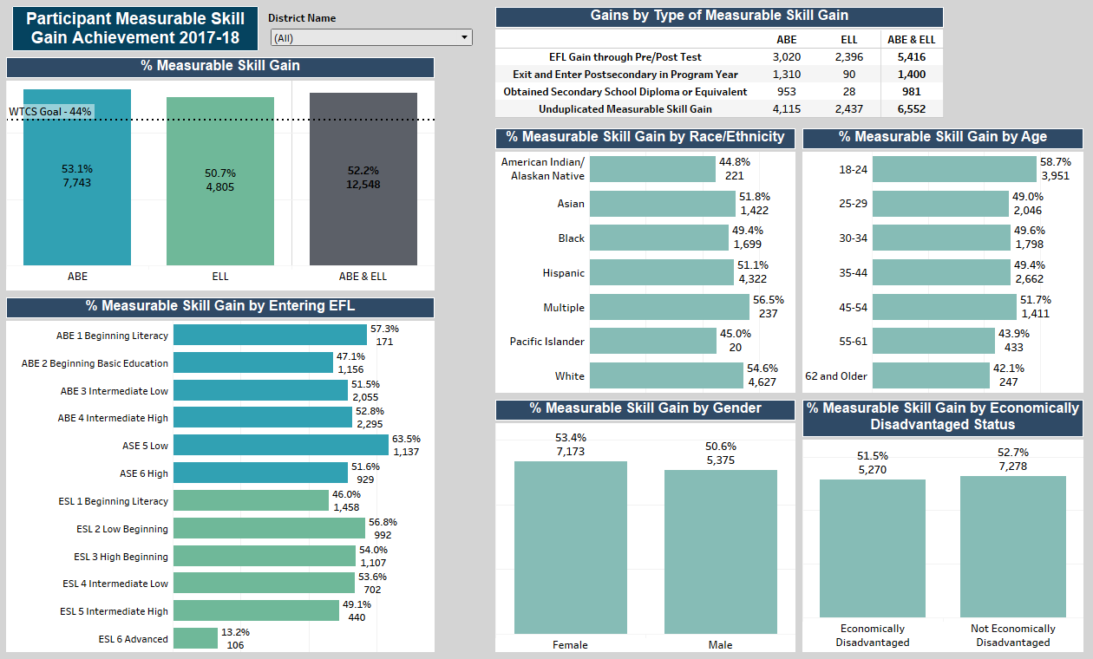
In April 2018, each AEFLA grantee was provided a three-page performance scorecard analyzing the participants served in their program, their organization’s pre- post-test rates, and their Measurable Skill Gain outcomes from the prior program year. This scorecard is shared with each grantee on an annual basis at the closing of each program year. Grantees were coached on how they could engage with the data through the effective use of data framework (see illustration below), and encouraged to continue having conversations related to performance back at their organizations and during future WTCS System Office coordinated professional development.
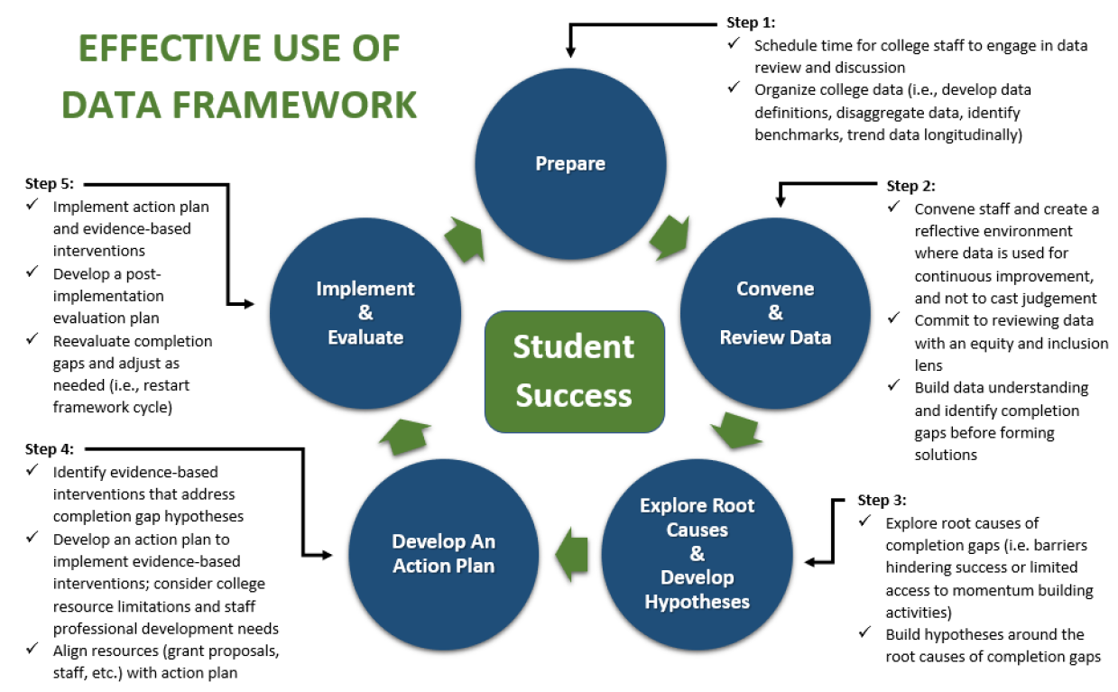

In support of reaching the future state-wide negotiated levels of performance, the WTCS System Office also developed and implemented an AEFLA Program Effectiveness Model. Under this model, each WTCS grantee will be held accountable to localized expected levels of performance. Each grantee will receive an Expected Level of Performance document by October 31 of each academic year with the intention that the program can plan activities to reach their expected levels of performance set for the subsequent academic year. For example, academic year 2019-20 expected levels of performance will be shared by October 31, 2018. The Expected Level of Performance document will identify grantee expected levels of performance, grantee actual levels of performance from previous academic years, and comparable WTCS performance across the WIOA performance indicators (as available once negotiated with the Department of Education).
Grantee expected levels of performance are the targets each grantee should strive for across each of the WIOA performance indicators. Expected levels of performance will be set on an annual basis by the WTCS System Office Accountability Team and the Adult Basic Education Team. Grantee expected levels of performance will be derived from:
- The grantee’s historical performance;
- The WTCS overall expected levels of performance;
- A continuous improvement approach where all grantees below the state WTCS expected level of performance will be requested to improve performance from the year before at a minimum of one percentage point; and
- A relative ranking approach where all grantees above the state WTCS expected level of performance will be requested to at least maintain performance from the year before.
All grantees will be accountable for each WIOA indicator that the WTCS System Office has negotiated with the Department of Education as outlined in the Expected Level of Performance document distributed each year. To meet an expected level of performance target, grantees must attain a grantee achievement rate of 90% or greater in relation to their identified expected level of performance for each WIOA indicator. For example, the table below shows that the grantee expected level of performance for employment rate in the 4th quarter after exit is set at 50%. The actual level of performance was reported to be 40%. With this information, the grantee achievement rate is calculated to be 80% (40% ÷ 50% x 100 = 80% grantee achievement rate).
Indicator | Grantee  Expected Level of Performance | Grantee Actual Level of Performance | Grantee Achievement Rate
Employment Rate 4th Quarter After Exit | 50% | 40% | 80%
Grantees who fail to meet the 90% grantee achievement rate will receive technical assistance from the WTCS System Office in the first year and will be required to implement a local improvement strategy. Repeated under-performance in the same WIOA indicator for two consecutive years may result in increased System Office intervention and technical assistance, and possible grant action e.g. grant awards become contingent on specified incremental progress.
To encourage grantee success, the WTCS System Office will provide the following to support program reflection and planning in reaching grantee expected levels of performance:
- A WTCS Framework for Effective Data Use to support grantees in convening teams to review data, identifying completion gaps, strategizing around evidence-based interventions, and creating local action plans for improvement;
- An annual WTCS WIOA Performance Indicator Scorecard specific to each grantee as well as WTCS overall performance for benchmarking purposes;
- A WTCS AEFLA Program Self-Study Assessment as a tool to reflect upon business processes and activities that could be improved or scaled across the program; and
- Professional learning opportunities through System Called Meetings and WTCS coordinated convenings that highlight evidence-based interventions to support program success.
Each grantee should report a summary of yearly activities enacted to reach the program's expected level of performance via the end-of-year WTCS triannual grant report due the November 1 after the end of the academic year (e.g., academic year 2019-20 reporting is due November 1, 2020). This information will be used as a method to monitor grantee progress and as a source of qualitative information that can be shared with the Department of Education to highlight program improvement.
3. Integration with One-Stop Partners
There was significant activity in this area, both with Wisconsin’s one-year AEFLA extension grantees (all extension grants ended on June 30, 2018) as well as with open competition applicants and eventual awardees (new AEFLA awards began on July 1, 2018.)
All extension grantees were required to sign assurances re-implementing the roles and responsibilities as a required partner in the one-stop delivery system as specified in 34 CFR § 463.415(b). Grantees also had to commit to complying with the requirements and expectations set forth in Wisconsin’s State Plan. All new applicants under the AEFLA open competition had to make the same commitments. All new applicants were also required to share key sections of their applications with their local workforce board leaders for review and comment. This looming requirement caused extensive discussions between Title II applicants and their local workforce board staff. WTCS AEFLA staff reviewed all the comments from workforce boards, which were almost universally positive and supportive.
Our Department of Workforce Development’s (DWD) process of certifying Job Centers was completed in spring of 2017. As this process was underway, draft Job Center Guidance was released by the Department of Workforce Development in late February 2017, and all AEFLA-funded providers received copies of this draft guidance as well as instructions on their roles at an AEFLA-grantees required statewide meeting. During the 2017-2018 year there were numerous face-to-face and virtual trainings on implementing this WIOA-related guidance. Guidance was given as to the nature of 1) Initial MOUs for partner roles, shared responsibilities, and operational policies, with a due date of June 1, 2017, and 2) MOUs for required local infrastructure contributions, with a due date of January 1, 2018. The WTCS also actively maintained a Frequently Asked Question document re Title II that addressed some of these issues and which included links to US Department of Education and Department of Labor guidance.
Wisconsin’s extension grant-funded Title II providers were already providing Career/Training Services as part of their one-stop partnership responsibilities, with a working history of coordinated assessment approaches, referral practices, public listing of program cost and outcome information, supportive services referrals, and the ABE/ELL portion of integrated career pathway bridge programming. These Title II-funded programs worked to improve how well they were tied into their shared AJC role during the year, and a key mechanism for getting this moving was the WTCS requirement that all Title-II funded programs be designated as local Workforce Development Area partners and be written into MOUs. A day of facilitated discussion and sharing in October of 2017 amongst the 11 regional groups of WIOA partners helped further unify their understanding of how they could best coordinate provision of these services.
Applicants for funding under the open competition participated in extensive WTCS professional learning and informational sessions related to the opening of grant competition. They were shown the application requirements in the new WTCS AEFLA Guidelines which had been reviewed and approved by OCTAE staff. These guidelines explicitly required compliance with all the requirements set forth in the Act, as well as with Wisconsin’s State Plan and with local Workforce Investment Board (WIB) activities. Information included the following:
- A comprehensive American Job Center must provide: 1) the career services listed in 20 CFR 678.430, 34 CFR 361.430, and 34 CFR 463.430; 2) access to training services described in 20 CFR 680.200; 3) access to any employment and training activities carried out under section 134(d) of WIOA; 4) access to programs and activities carried out by one-stop partners listed in 20 CFR 678.400 through 678.410, 34 CFR 361.400 through 361.410, and 34 CFR 463.400 through 463.410, including the Wagner-Peyser Act ES program; and 5) access to workforce and labor market information.
- AJC partners may deliver WIOA career services in one of three ways: 1) having a program staff member physically present at the American Job Center; 2) having a staff member from a different partner program physically present at the American Job Center and appropriately trained to provide information to customers about the programs, services, and activities available through all partner programs; or 3) making available a direct linkage through technology to a program staff member who can provide meaningful information or services.
The new guidelines and this related professional learning made it explicit that:
- Applications for Title II funding would be provided to Workforce Investment Boards for review and comment.
- Wisconsin’s WIOA vision includes an intensive commitment to partnerships (both vertical among ABE service providers and horizontal across WIOA Titles).
- Mindful design of coordinated and integrated service between partners will provide excellent service to Wisconsin’s WIOA clients as well as improved results on our shared accountability measures.
Besides the ongoing local discussions between core and other partners described above, joint state-level work continued throughout the year. To assist and reinforce planning efforts, DWD and WTCS Title II-funded staff have regularly discussed key issues in interagency workgroups that are coordinating a variety of efforts including WIOA data governance and common intake, WIOA training and messaging, updating the state’s Eligible Training Provider registry, provision of coordinated professional development, etc.
4. Describe how the state is using funds under Section 243 to support the following activities under the IELCE program.
Describe when your State held a competition [the latest competition] for IELCE program funds and the number of grants awarded by your State to support IELCE programs.
The WTCS held a competition for AEFLA funding in the 2017-2018 year, with awards being made as of July 1, 2018. Therefore, in 2017-2018, the WTCS had not yet held a competition for Integrated English Literacy and Civics Education (IECLE) under the new WIOA law for Title II (Pub. Law 113-128) that requires states to provide IELCE Programs (AEFLA Section 243). During FY 2017-18, funds distributed to twenty-four (24) providers of IELCE under a grant extension. These programs provided instructional services in English literacy and civics education to more than 1,000 adult learners across the state. Instruction in English literacy were provided to adult learners enrolled in the first four (4) levels of the English Language Learning (from ELL Beginning Literacy thru ELL Intermediate Low) including language development activities related to reading, writing, speaking, listening, math and critical thinking/problem solving.
Describe your State efforts in meeting the requirement to provide IELCE services in combination with integrated education and training activities.
Integrated English literacy in combination with civics education is a special focus for the state, and in 2017-2018 WTCS committed a significant portion of the AEFLA funds for providing IELCE for adult English language learners, with 24 programs receiving funds for the provision of IELCE.
Describe how the State is progressing towards program goals of preparing and placing IELCE program participants in unsubsidized employment in in-demand industries and occupations that lead to economic self-sufficiency as described in section 243(c)(1) and discuss any performance.
WTCS has worked diligently with AEFLA providers of IELCE to ensure that all providers of IELCE are aligning their services with local workforce investment boards; the alignment will facilitate that IELCE participants are being prepared and placed in integrated education and training (IET) in high demand occupational, sustainable jobs. Monitoring via tri-annual reports was undertaken to make sure that instruction in English literacy is meeting the instructional standards to facilitate transition into PSE and/or unsubsidized employment. Additionally, IELCE providers are monitored to make sure that adult learners are receiving instruction in workforce preparation and occupational skills training where appropriate.
Describe how the State is progressing towards program goals of ensuring that IELCE program activities are integrated with the local workforce development system and its functions as described in section 243(c)(2) and discuss any performance results, challenges, and lessons learned from implementing those program goals.
Again, WTCS worked with IELCE providers to ensure that the programming for IELCE was aligned with the strategic directions of the local boards. The alignment also assisted IELCE participants for placement in integrated education and training (IET) in occupations in high demand in their respective regions; this approach facilitated achievement of self-sufficiency for participants in these programs.
We monitored the tri-annual reports to ensure that instruction in English literacy was meeting the instructional standards to facilitate transition into PSE and/or unsubsidized employment. Additionally, we monitored IELCE providers to make sure that adult learners were receiving instruction in workforce preparation and occupation skills training where appropriate.
In terms of performance results, challenges and lessons learned, WTCS has ensured throughout the grant extension guidelines that providers of IELCE programs were connected and aligned with services offered by Title I to facilitate the concurrent enrollment and training for all participants of IELCE program as described in section 243(c) (2) of new WIOA Law for Title II (Pub. Law 113-128) -- the mandate that required states to provide an Integrated English Literacy and Civics Education (IELCE) Program.
5. Adult Education Standards
During the 2017-2018 fiscal year, English Language Arts (ELA) and math projects have reached expected benchmarks in terms of having curriculum aligned to the WTCS Adult Basic Education standards, which themselves are aligned to the College and Career Readiness (CCR) Standards. The new curriculum will provide students with an adult experience, support ABE students in making a seamless transition into college or career and is available through the Worldwide Instructional Design System (WIDS) repository. Full day workshops and informational sessions were held at the 2017 Common Ground Conference in October 2017, and progress continues at individual program sites.
During the upcoming fiscal year, English Language Learning (ELL) groups will continue their work aligning the ELL curriculum to the WTCS CCRS-aligned ABE standards. The groups will convene several times during the fall of 2018.
6. Programs for Corrections Education and the Education of Other Institutionalized Individuals – What was the relative rate of recidivism for criminal offenders served? Please describe the methods and factors used in calculating the rate for this reporting period.
Wisconsin has adopted the Wisconsin Department of Corrections (DOC) definition of recidivism for narrative reporting purposes. The Wisconsin DOC defines recidivism as a new offense resulting in a conviction and sentence to the Wisconsin DOC after release. While Wisconsin uses the DOC definition, it is important to know all students served are housed in county jails. There are three key components to the Wisconsin recidivism rate calculation, which are:
Starting Point: the timeframe in which the cohort being examined for recidivism is determined;
Follow-up Period: the three-year timeframe during which each cohort is tracked for recidivism;
Recidivism Event: the act/event resulting in conviction and the date on which the act occurred.
The following visual helps illustrate the definition of these components.
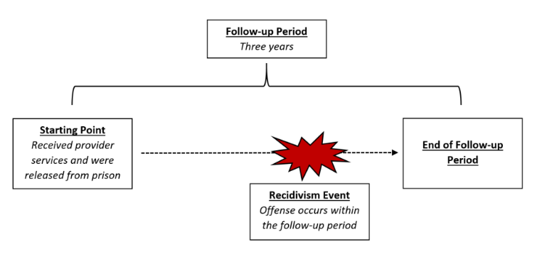
Wisconsin has held informational sessions to share the recidivism-reporting requirement with providers, and has early results related to recidivism rates within the 2015-16 and 2016-17 recidivism cohorts: 486 institutionalized individuals received 12 hours of service or more and were released during the 2015-16 program year. Of the 486 released individuals, 98 recidivated within one year of release, resulting in a recidivism rate of 20 percent. The 2015-16 recidivism cohort will be tracked an additional two years to assess the three-year recidivism rates defined by the Wisconsin DOC.
After collecting and analyzing the data from our service providers for the second reported cohort (July 1, 2017 – June 30, 2018), there were 402 institutionalized individuals who received 12+ service hours and were released during the program year. Of the 402 released individuals, 82 recidivated within one year of release, resulting in a recidivism rate of 20 percent. When looking at the combined totals for each reported cohort to date, the total number of institutionalized individuals that were released is 888 and the combined total of individuals who recidivated is 180. This results in a combined total recidivism rate of 20 percent for the state of Wisconsin.

