State Leadership Funds (AEFLA Section 223)
(A) Describe how the State has used funds made available under section 223 (State Leadership activities) for each the following required activities:
- Alignment of adult education and literacy activities with other one-stop required partners to implement the strategies in the Unified or Combined State Plan as described in section 223(1)(a).
- Establishment or operation of a high-quality professional development program as described in section 223(1)(b).
- Provision of technical assistance to funded eligible providers as described in section 223(1)(c).
- Monitoring and evaluation of the quality and improvement of adult education activities as described in section 223(1)(d).

(B) As applicable, describe how the State has used funds for additional permissible activities described in section 223(a)(2).

(A.1) Alignment
Alabama strategically allocated and expended funds under section 223 (State Leadership activities) to provide and enhance educational and training services for implementing the strategies of the WIOA State Plan. Alabama’s six (6) core partners under the major core components of the Workforce Innovation and Opportunity Act are in four (4) different agencies: Title I, Alabama Department of Commerce; Title II Adult Education, Alabama Community College System; Title III, Alabama Department of Labor; and Title IV, Alabama Department of Rehabilitation Services. Over the last year there has been an intensified effort to expand training opportunities to job seekers. Leadership funds have been used to support the integration and expansion of training services to be delivered within the Career Center system. Alabama adult education has been looking at rebranding itself to be more in tuned to a skill training focus.

Adult Education (AE) is co-located in all Comprehensive Career Centers and most of the affiliates throughout the state. The services provided through Adult Education in the Career Centers continue to grow beyond traditional academic and High School Equivalency preparation. Under WIOA, Adult Education and the Career Centers have elevated their partnership to include an integrated education and training approach that places adults on a pathway to successful employment and increased earning opportunities. The Adult Career Pathway program provides a pathway opportunity for adults. Partner funding is utilized to support technical training. Basic academics are contextualized and integrated with technical education skills. Adults attain stackable, industry recognized credentials and certificates along an educational path with multiple entry and exit points.

All adult education providers are encouraged to provide Integrated Education and Training (IET) to accelerate the learning process. Adult education funds are leveraged with other WIOA partner funds to support the IET program model. A specific program requested through the local workforce boards is Ready To Work (RTW). RTW is a soft skills training that incorporates financial literacy, digital literacy, and contextualized academics to prepare adults for employment opportunities in manufacturing and beyond. At the request of the local area workforce boards, a lower level precursor to RTW called Workplace Success was created and piloted to assist adults that were functioning at lower levels of literacy. The Workplace Success program assisted adults reading below a 6th grade level to attain the RTW workplace skills but at a very basic level.

Another example of collaboration between state partners to meet the objectives of the state plan can be seen from the 2017-18 Memorandum of Agreement (MOA) between the Alabama Department of Human Resources (ADHR) and Alabama Community College System, Adult Education Workforce Division. This partnership created integrated education and employability skills training opportunities to the Temporary Assistance for Needy Families (TANF) population. The training prepares clients for employment opportunities through the blending of academic and technical training and workforce preparation skills. ACCS and ADHR also has an agreement to serve the Supplemental Nutrition Assistance Program (SNAP) clients. The SNAP partnership is like the TANF partnership because it utilizes the same training approach, but it is a braiding of state/federal match. All these initiatives are focused on the embedded academic and job training needed to attain skills and industry recognized credentials for employment in the various sector areas including construction, manufacturing, healthcare, transportation, information technology, and the service industry.

Leadership funds, state funding, and braided resources from partners were utilized for statewide implementation of these workforce skills training efforts. We are continuing to grow and enhance the offerings and are very pleased with current partnerships and outcomes. Current and future certification training opportunities for adult education students will include the Manufacturing Skill Standards Council certification for Certified Production Technicians (CPT), Certified Logistics Assistant (CLA) and Certified Logistics Technician (CLT).
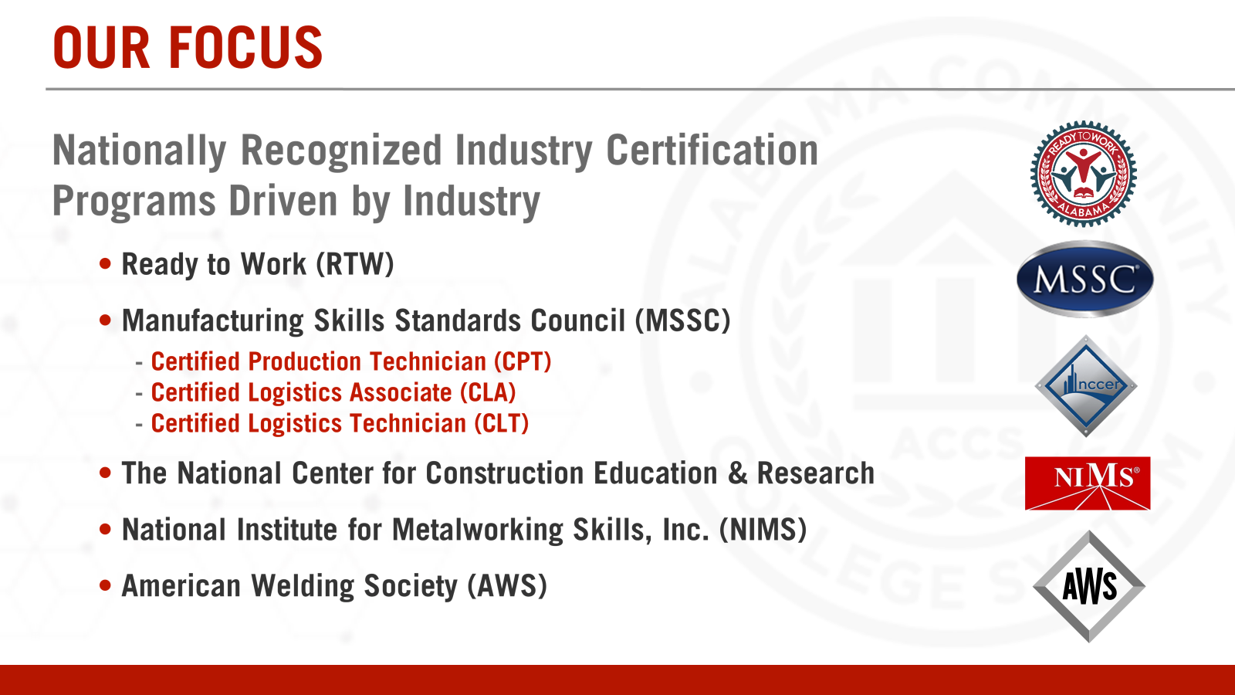

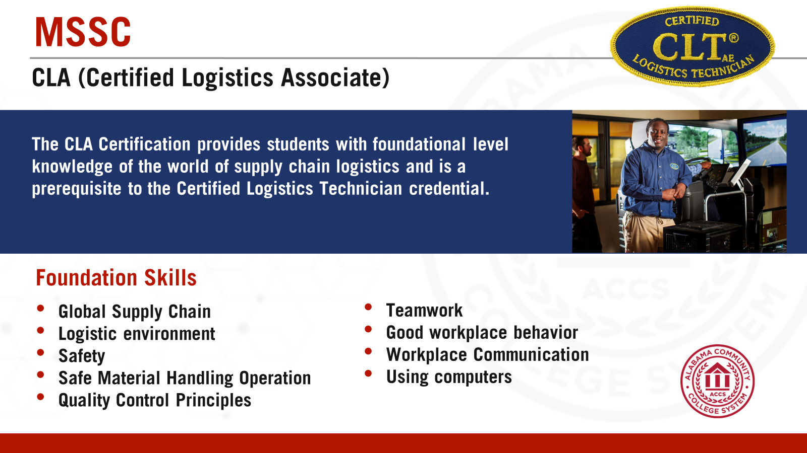

(A.2) Professional Development
Adult education practitioners must be prepared to provide the highest quality instruction so that our workforce has the 21st century skills to be successful. High quality and ongoing professional development opportunities are essential to prepare instructors for the demands of the future. Practitioners must have the strategies and knowledge to prepare students with basic skills for the high school equivalency and beyond. Utilizing the Workforce Innovation and Opportunity Act as the impetus to be innovative in professional development training, the state collaborated with partners to create professional learning opportunities that incorporated both face to face and virtual.

Alabama continued the commitment to excellence by offering professional development opportunities to ensure growth and understanding of the implementation of the WIOA state plan. In February, the state held a statewide convening of WIOA partners. Adult Education program directors and practitioners were in attendance for the 3-day Workforce event. We have seen an increase in the understanding and expectations of the role of adult education.

Additional professional development training in Alabama is delivered through a multi-faceted approach. The model incorporates nationally recognized evidence-based strategies. Strategies include face to face, distance education, and hybrid models. The trainings feature a common set of criteria for illustrating and assessing program practices. Essential elements of professional learning that leads to change in educators’ practices and improved student outcomes.

Leadership funds were used to support professional development in the area(s) of college and career readiness standards, integrated education & training, career pathways, integrated English Literacy Civics Education, instruction in Reading Language Arts, Mathematics, Science, and Social Studies, and supporting individuals with learning challenges. Below are just some of the ongoing PD offerings during the program year:

Academic Bridge Preparation Programs Workforce Innovation and Opportunity Act (WIOA)
Co-Enrollment IET Activities (AE and Technical Skills) Alabama Career Centers and Regional Councils
Career Pathways & Contextualized Instruction “Workforce Essential Skills” Soft Skills/Employability Skills
Data Management System Webinars- monthly Series Math/RLA
Technology Integration into classroom instruction Corrections/Institutionalized Classes
Virtual Distance Education Integrated English Literacy Civics Education
GED® Preparation CCR Standards College and Career Readiness Standards

National conferences, institutes, and trainings that were attended by Alabama adult education practitioners included the Council on Adult Basic Education (COABE) face to face and virtual, National Career Pathway Network (NCPN), South East Training Alliance (SETA) and the GED® Testing Service Professional Development Conference.

(A.3) Technical Assistance
The state is dedicated to continuous program improvement so technical assistance support is provided continuously and in various forms. In the 2017-18 program year the state enhanced support efforts by assigning a program specialist and accountant to each program. There were four program specialists and two accountants that provided guidance in areas such as performance, instruction, assessment, data collection, reporting, recruitment, retention, and fiscal management. Specific areas of focus included IELCE, Career Pathways, WIOA integration, IET models, employability skills training, partnership development, and high school equivalency.

Technical assistance is provided through face to face (F2F) trainings, webinars, emails, phone calls, and teleconferences. A bi-weekly webinar series for programs called “Spotlight” is a constant. This PD opportunity highlights and discuss topics and best practices relevant to the local programs. The state uses the forum to disseminate policy, regulations, innovative instructional strategies and resources from a national, state, and local level. Questions are asked verbally or through the chat feature. The Spotlight series is recorded and archived as a professional development resource for directors and staff through the Alabama Adult Education System of Performance and Accountability (AAESAP) management information system.

(A.4) Monitoring and Evaluation
Monitoring and evaluations are accomplished in a couple of different ways. Desktop monitoring and actual on-site review visits make up the process used to evaluate the success and/or areas for program improvement. A desktop monitoring process utilized based on the National Reporting System (NRS) Educational Functioning Levels (EFL), Measurable Skill Gains (MSG), High School Equivalency attainment, postsecondary education, training, and employment is utilized. Alabama included four additional state indicators in FY 2017-2018 year to include: 1) an enrollment goal, 2) an overall academic performance measure goal, 3) a National Career Readiness Certificate goal, and 4) a goal for GED® diplomas. The process also takes into consideration attendance patterns, pre/posttest rates, and invoicing patterns. After the completion of the desk audit, programs are contacted by phone, email, or a visit. Programs are required to follow-up on how to increase performance if the program is within a range which would be unacceptable based on the current time of the year that the desk audit is generated. The state continues to revise and adapt new features to the compliance review and technical assistance process.

Program effectiveness is gauged through the federal measures as outlined under the federal WIOA and NRS measures. Programs with low performance in the federal and state indicators are given continuous support by their specialist.

B. Permissible Activities
During the 2017-18 program year leadership funds were used to support the Alabama Adult Education System of Accountability and Performance (AAESAP). The data management system continues to expand functionality in order to capture, match, and report WIOA data.

Performance Data Analysis
Describe how the adult education program performed in the overall assessment of core programs based on the core indicators of performance. Discuss how the assessment was used to improve quality and effectiveness of the funded eligible providers and any plans to further increase performance in future reporting years.

Alabama has 67 counties in the state with 25 fiscal agents providing services in each county. These 25 providers account for over 400 locations and 1,040 classes. The adult education system has a staff of 783, including volunteers. Part-time staff (less than 19 hours a week) makeup 75% of the total staff. During the 2017-18 program year there were 25 designated program directors with many of those positions being filled by temporary appointments. Retirements during the 2017-18 year as well as several changes in local program leadership resulted in inconsistency in local program performance.
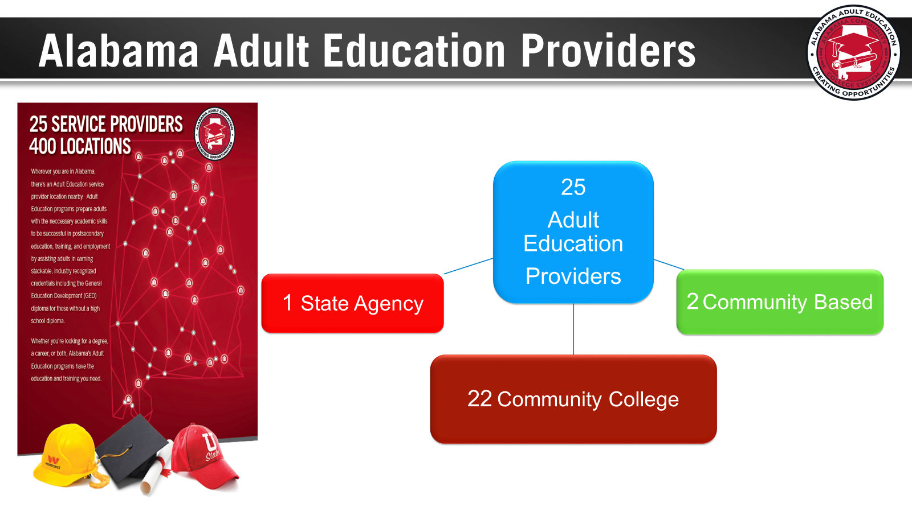

Alabama Adult Education follows a continuous improvement approach with data analysis as the foundational base. The state has been relatively consistent with historical norms for the core indicators of performance and the population demographic served.

Alabama Adult Education
Educational Functioning Level (EFL) | 2017-2018 EFL Enrollment (12 hours +) | 2017-2018 EFL Completion Percentage
ABE Beginning Literacy | 416 | 31%
ABE Beginning Basic | 2,486 | 35%
ABE Intermediate Low | 4,809 | 39%
ABE Intermediate High | 5,716 | 44%
ASE Low | 2,487 | 54%
ASE High | 1,577 | 47%
ESL Beginning Literacy | 713 | 26%
ESL Low Beginning | 419 | 36%
ESL High Beginning | 400 | 37%
ESL Low Intermediate | 362 | 34%
ESL High Intermediate | 266 | 33%
ESL Advanced | 113 | 20%
Total | 19,764 | 41%

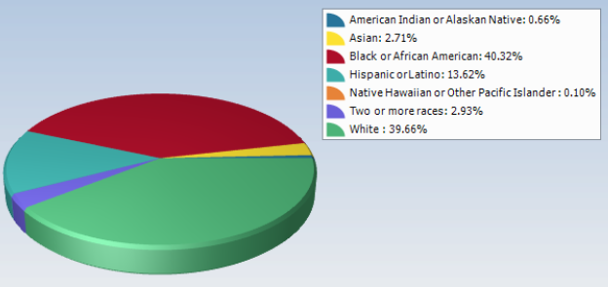

Important state data which is not reflected in the NRS data is the number of work ready certifications earned through adult education. A couple of the state recognized certifications are the National Career Readiness Certification (NCRC) and the Alabama Certified Work Ready Credential (ACWRC). The number of National Career Readiness Certifications (NCRC) based on the ACT Work Keys assessments increased from 2,500 to 2,691. Also, the state awarded over 300 ACWRC to adult education students that completed the Ready To Work program.

The challenge for adult education is the additional expectations required of instructors to prepare an increasingly younger population of participants (millennials) for a high school equivalency based on higher standards and equip them with the skills based on labor market demands. Instructors are in many cases, several generations removed from the adult (average age 28) that is coming to our programs. The generational gap creates an obstacle to the alignment of skills required by employers and possessed by the adult education population. One way that the state attempted to address this issue, beyond just the CCR standards training, was to collaborate with the Alabama Department of Labor to offer a specific labor market information training throughout the state in over 20 locations with over 60 sessions offered. The training assisted career center professionals and adult education practitioners in using the tools available to align services to the needs in the area and to prepare the jobseeker for employment.

The functionality and reporting features of the management information system continues to advance. Our system is known as the Alabama Adult Education System for Accountability and Performance (AAESAP) which is designed to capture the requirements under WIOA and to provide instant feedback for data analysis. During the last year, we increased the capabilities of the system features such as dashboards, alerts and reports. The dashboard emphasizes federal and state performance goals for both a program year and state fiscal year. The automated alerts include testing and attendance. Detailed local and state reports allow programs to self-assess and make data driven decisions for improving services. The financial reporting module tracks the allocation and expenditure of funds. During the 2017-18 program year an entire resource section was created within AAESAP to allow instant access to national and state specific informational sources and training presentations.

Additional information for consideration is that the Alabama’s unemployment rate last year was around 3.5%. However, the state’s labor force participation rate is the third lowest in the nation at 57.3 percent. The challenge is to reach those that are underemployed, unemployed, and those that are not currently participating in the labor force. Employment is a motive to engage students in adult education, but it can also be a factor in students leaving the program before meeting performance measures. This type of influence must be taken into perspective when evaluating the success of a program.

Integration with One-stop Partners
Describe how the State eligible agency, as the entity responsible for meeting one-stop requirements under 34 CFR part 463, subpart J, carries out or delegates its required one-stop roles to eligible providers. Describe the applicable career services that are provided in the one stop system. Describe how infrastructure costs are supported through State and local options.

The Alabama Community College System, Adult Education Division is responsible for the requirements under 34 CFR part 463, subpart J, and carries out this responsibility. Adult Education provides adult education services as stated under 34CFR part 463, subpart J, throughout the state in the designated comprehensive career centers and in the affiliate career centers where possible. Adult Education has fulfilled a vital part of the assessment and training role in the career centers. The relationship between the partners is one that fosters and demands collaborative teamwork. Education and training services between partners are provided through direct referral and reverse referral. The services provided in the one stop system is described in more detail in the State Leadership section under Alignment.

Infrastructure costs are directly charged to each partner based on square footage for those that are co-located. The state adult education office provides the financial support for each local program’s fair and equitable share of the infrastructure costs based on benefit received and as determined through the funding formula created by the Alabama Department of Labor.

Integrated English Literacy and Civics Education (IELCE) Program (AEFLA Section 243)
Describe how the state is using funds under Section 243 to support the following activities under the IELCE program:
- Describe when your State held a competition [the latest competition] for IELCE program funds and the number of grants awarded by your State to support IELCE programs.
- Describe your State efforts in meeting the requirement to provide IELCE services in combination with integrated education and training activities;
- Describe how the State is progressing towards program goals of preparing and placing IELCE program participants in unsubsidized employment in in-demand industries and occupations that lead to economic self-sufficiency as described in section 243(c)(1) and discuss any performance results, challenges, and lessons learned from implementing those program goals; and
- Describe how the State is progressing towards program goals of ensuring that IELCE program activities are integrated with the local workforce development system and its functions as described in section 243(c)(2) and discuss any performance results, challenges, and lessons learned from implementing those program goals.

Alabama Adult Education allocates funding under section 211(a)(2) to support all the activities as described in section 243 for the Integrated English Literacy and Civics Education (IELCE) program. The goal is to prepare adults who are English language learners for unsubsidized employment in the in-demand industries and occupations in Alabama which lead to economic self-sufficiency. These efforts are supported and assisted through the local Career center.

State Held Competition
Alabama Adult Education offered a competitive, multi–year (three year) Request for Funding Proposal (RFP) that included IELCE funds. Competition for funding and the distribution of awarded funds were competed according to the process described in the Title II distribution of funds Common Elements section of the Alabama State plan and complied with the requirements of Subpart C section 243 of WIOA. The competition was held in February of 2018. There were 11 IELCE programs selected during the competition and the start date for services for the new entities began July 1, 2018. Prior to the competition there were 10 IELCE programs funded through a continuation status of a previous competition

IELCE services in combination with IET activities
Each program that receives funding under this section shall be designed to (1) prepare adults who are English language learners (ELL) for, and place such adults in, unsubsidized employment in in–demand industries and occupations that lead to economic self–sufficiency and (2) integrate with the local workforce development system and its functions to carry out the activities of the program.
The Alabama Adult Education state office considered the ELL population in each regional local workforce service area for determining the IELCE allocation. The eligible provider aligned the need and services to the mission and requirements of the WIOA state plan and the labor market information in each area. The IELCE funds targeted those areas of the state with large population of English language learners. The skills to improve one’s abilities to read, write, speak the English language, and become a productive citizen with sustainable employment is integrated with skills that will prepare the ELL learner for employment opportunities.
Integrated English literacy and civics education are educational services provided to English language learners who are adults, including professionals with degrees and credentials in their native countries, which enables such adults to achieve competency in the English language and acquire the basic and more advanced skills needed to function effectively as parents, workers, and citizens in the United States. These types of services shall include instruction in literacy and English language acquisition and instruction on the rights and responsibilities of citizenship and civic participation. They will also include workforce training. An example of this is including the IELCE students in the Adult Career Pathways, Bridge, and Ready to Work programs.
An evidence–based approach using the framework of Integrated Career Pathways is used for the non–skilled or skill deficient adults in our state who are non–native English language learners. Instructors from the ELL program and the workplace, career technical education programs integrated instructional models to effectively and efficiently train the student. The IELCE program seamlessly prepares English Language Learners for employment opportunities.
Preparing and Placement in Unsubsidized Employment and In-Demand Industries
The state continues to expand training opportunities for the ELL population. Multiple efforts are currently underway to ensure adult education and IELCE students are afforded opportunities in the high demand areas of manufacturing, healthcare, and construction to name a few. An example is the automobile industry and the protein processing plants in Alabama. In manufacturing one of the major players in this collaboration is Mercedes and their Tier 1 and 2 suppliers. Tyson and Pilgrim’s pride is an example of two collaborative partners in the protein processing plants.

Providers design programs that deliver the activities under WIOA including the integration of literacy and English language instruction with occupational skill training. Providers will also promote linkages between students and potential employers. Providers must prepare English Language Learners for unsubsidized employment in demand industries and occupations that lead to economic self–sufficiency. The activities of the program must reflect the needs of the local, regional workforce area. Civics education, embedded with training, is an integral part of the English language acquisition services for the ELL population. English literacy and civics education classes introduce students to civics–related content and provide them with opportunities to apply that knowledge in their daily lives while building their English language and literacy skills for the workforce. The skills learned in these classes strengthen the ELL adult’s ability to be an active participant and contributor to our communities, workforce, and local economies.

Integration with Local Workforce Development System
An increased emphasis is being placed on college and career readiness standards for IELCE participants to prepare them for additional training and/or employment opportunities. Providing targeted IET professional development to the IELCE instructors is crucial in preparing the English language learner population for the workforce. Two state specialists have been designated to ensure that IELCE programs are fully implementing the IET pathway activity requirement. Activities must include preparation of the ELL participants for employment opportunities in the in-demand industries with full coordination with the local workforce system (example of in-demand industry collaboration was provided in previous section). The coordination of placement services through the career center partners and community college system connects the IELCE jobseeker to employers. The state workforce system through the community college system is launching an Industry Recognized Apprenticeship Program (IRAP) to provide comprehensive support, resources, and on-the-job training opportunities for jobseekers which includes the adult education, corrections, and IELCE populations. Our goal is to continuously improve and enhance services to all populations, including the IELCE.

Adult Education Standards
If your State has adopted new challenging K-12 standards under title I of the Elementary and
Secondary Education Act of 1965, as amended, describe how your Adult Education content standards are aligned with those K-12 standards.
- Optional – Describe implementation efforts, challenges, and any lessons learned.

Alabama Adult Education has adopted the College and Career Readiness (CCR) standards disseminated through the Office of Career, Technical, and Adult Education (OCTAE). These standards were developed for Adult Education in the area(s) of Reading Language Arts (RLA) and Mathematics to align with the rigor of the national K-12 standards. Directors and instructors are part of continuous professional development that support the implementation of the CCR standards. The CCR standards are the instructional blueprint used in preparing adults for education and training beyond a high school equivalency. The standards themselves provide our instructors with the objectives that students must attain to be successful. Instructors use these objectives to create the instructional path to hold themselves and students accountable for results. Local programs utilize a Plan of Instruction (POI) document for each student. The POI is required and allows the instructor to create a targeted instructional path to lead to successful outcomes.

Training has occurred in multiple formats including workshop sessions, webinars, and facilitated distance education semester-long courses. National and state level experts are used in disseminating the standards. For example, the National Center for Family Learning conducted a semester-long online training for directors and instructors. Another example is the continuous support from the GED® Testing Service with workshops and webinars on GED® test alignment to the CCRS. Also, programs benefitted from the online standards courses offered through LINCS. The challenge in any process is making sure that implementation occurs. Continuous follow-up and monitoring are used to support and ensure implementation. There were 16 adult education practitioners which included state staff, local directors, and instructors in attendance during the National CCR standards trainings. A core working group was formed after the national training for improving the process of statewide training efforts and implementation around standards and innovative instructional strategies.
Skills Gap in STEM Jobs
- Alabama is a STEM-rich state. However, there are significant gaps in access to STEM discovery, learning, and career pathways.
- Labor market projections indicate a growing gap in the supply of qualified employees for middle skills jobs.
- Shortfalls are expected to be particularly acute in STEM fields, such as computer technology, nursing, and advanced manufacturing.
- Thirty-four of Alabama’s 40 Hot Demand Occupations require secondary and postsecondary STEM education.
- Between 2017 and 2027, STEM jobs will grow by 9 percent in Alabama, while non-STEM jobs will only grow by 5 percent.

Programs for Corrections Education and the Education of Other Institutionalized
Individuals (AEFLA Section 225)
What was the relative rate of recidivism for criminal offenders served? Please describe the methods and factors used in calculating the rate for this reporting period.

Alabama has a statewide recidivism rate of 21.9% for those that were served through adult education programs. This rate was determined by using the number of adult education students served through corrections education from three years ago (State fiscal year October 1, 2015 to September 30, 2016). Those records were matched with the Alabama Department of Corrections to determine the number of inmates released and the number of those that were reincarcerated. The state fiscal year time period was used to better align with Alabama Department of Corrections (ADOC). According to the ADOC, the current overall recidivism rate for the state of Alabama is 31.9%. {A recidivist is defined as an inmate who returns to the ADOC prison system within three years of release from an ADOC jurisdiction}

Detail of the process: Through the Alabama Adult Education System of Accountability and Performance (AAESAP), there were 3,646 students identified as being enrolled in adult education programs for FY 16 (Oct. 1, 2015 – Sept. 30, 2016). The Alabama Department of Corrections was able to determine by a data match that 1,753 of those students had been released. Out of the 1,753 released students, 384 have returned to prison— a recidivism rate of 21.9%.

As you can see from the data match, adult education reduces recidivism. This information has been used to foster discussions with the ADOC to expand education and training opportunities for inmates in all correctional facilities in the state. Current expansion efforts are scheduled for 2019.

