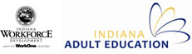
Indiana Narrative Report 2013-2015
In Program Year 2014-15 (PY 2014), the Indiana Department of Workforce Development (IDWD) continued to drive toward increasing enrollments, outcomes and partnerships. Additionally, IDWD continued to focus on innovative models of instruction and effective professional development to move the system toward its vision of adult education programming that leads to successful career pathways, postsecondary transitions, and employment.

State Leadership Funds:
Describe the major activities supported with State Leadership funds during the reporting period and the extent to which these activities helped you in implementing the goals of the State plan. Specifically describe activities related to the implementation of career pathways.

DWD continues to offer an aggressive professional development schedule of programs in response to the gaps identified by an intensive needs survey and evaluation conducted during PY 2011. State leadership funds supported the following successful programs and activities:

      - 2014 Summer Institute – IDWD hosted a 3-day event, with several tracks to support the various topics within the Adult Education field, e.g., English as a Second Language, College and Career Readiness, High School Equivalency Assessment. This event focused on keeping calm in light of shifts occurring in the adult education system and pursuing evidence-based strategies to help students transition beyond a High School Diploma or Equivalency Diploma.
      - Administrator meetings – In addition to the annual meeting of local AE Program Directors, IDWD provided additional administrator advisory meetings this reporting period that covered the following topics: adult education policy and programs; high school equivalency testing, transitions, professional development, serving youth under WIOA (holding a special joint Adult Education Director and Youth Manager meeting in November), WorkINdiana and on-going implementing of IDWD’s Adult Education strategic vision.
      - Adult Numeracy Institute (ANI)& (AR)^2 – See the Adult Education Standards section below.
      - 2014 Fall Teacher Meeting – This day-long training introduced Adult Education Teachers and transitions staff to the Search Institute's foundational framework: Everyone's an Asset Builder and Sharing the Asset Message and corresponding strengths-based developmental approaches for working with young people. This training also focused on new WIOA requirements for increasing services to out-of-school youth.
      - Workgroups – IDWD continuously seeks feedback and collaboration form Adult Education administrators and teachers in building topics and content for Professional Development events and activities. IDWD continues to host workgroups to assist in the development and delivery of future professional development in Indiana. In this reporting period IDWD convened the following workgroups: Adult Education WIOA Work Group, and Teacher Induction & Competencies Work Group.
      - AmplifyAE & Blackboard – DWD continues to utilize and upgrade the AmplifyAE.org website, which houses all of the materials developed for professional development events as well as additional resources. This reporting year focused on adding the ability to register for events through this website. The addition of Blackboard as an online learning management system has allowed IN AE to deliver more distance learning options to local program staff seeking professional development & technical assistance. During this reporting period Blackboard was incorporated into the ESL-4-ESL, SIA, and Teacher Induction & Competencies Projects.
      - Standards In Action (SIA) - See Adult Education Standards section below.
      - Annual Directors Meeting – IDWD offered this annual event that focused on exciting changes taking place in the field of adult education and the larger workforce system due to the new WIOA legislation. Best practices from the participants in the Administrator 500 Leadership Series were shared to place emphasis on high quality instructional leadership and evidence-based approaches to delivering adult education.
      - Integrating Career Awareness (ICA) Online Course & Study Circle – IDWD partnered with LINCS to offer a six-week, online course to prepare instructors to implement the Integrating Career Awareness into the ABE & ESOL Classroom Curriculum Guide in the fall. A study circle covering similar content was delivered, again in partnership with LINCS, in the spring.
      - LINCS Online Courses: Using Wiggio as a discussion and assignment posting/grading forum, IDWD utilized four LINCS Learning Portal courses to offer facilitated online courses for AE and workforce development local program staff. Topics included: Adult Career Pathways (ACP): Integrating Career Counseling and Planning, ELL-U: Second Language Acquisition - Myths, Beliefs, and What the Research Shows, LINCS Science: Scientific Practices in Context, LINCS Integrating Technology in the Adult Education Classroom.
      - Administrator 500 Leadership Series – IDWD offered this year-long professional development initiative that focuses on innovative leadership to impact positively program outcomes.
      - ESL-4-ESL – See Adult Education Standards section below.
      - InTERS Trainings - IDWD continues to deliver trainings for local program staff on data reporting and the use of Indiana’s InTERS data collection and management system.

IDWD continues to invest heavily in building the adult education professional development system. The above activities directly tie to the overall vision of ensuring that adult education students have the opportunity to earn both a high school equivalency diploma and an occupational credential that leads to high-value career opportunities. In total, roughly 600 Indiana adult education practitioners (directors, teachers, paraprofessionals, counselors, and volunteers) participated in at least one professional development meeting, which equates to roughly 66% of the total population (based on NRS Table 7).

Performance Data Analyses:
Describe any significant findings from the evaluation of your performance data for the reporting period and efforts to improve outcomes for the core indicators of performance.

PY 2014 Performance Outcomes
28,107 | - Student Enrollments  - 5% decrease over PY 13
22,858 | - Level Gains (student may have achieved more than one gain)  - .5% increase over PY 13
5405 | - HSEs and HS Diplomas Awarded  - 20% decrease over PY 13
1101 | - WorkINdiana Enrollments  - 1% increase over PY13  - 85% completion rate  - Of those who completed, 79% earned certification

DWD has a system of state performance metrics in addition to the federal measures required under the National Reporting System. Above is a summary of outcomes that state staff shares broadly with practitioners in the field. PY14 saw another decrease in enrollments. This decrease seems to be following the national decrease in enrollments in Adult Education, and Indiana has set ambitious goals for reversing this trend over the next 5 years by asking the field to double enrollments between now and 2020

There was another decrease of High School and HSE Diplomas awarded during this program year as well. It seems that the continued decrease over the past two years is a residual effect of the change in assessment. However, when looking over the last several years of data (see chart below), including the transition year, switching from the GED to the TASC test, it appears that the decreases have stabilized.
Program Year | # of HSEs awarded
2010 | 4,848
2011 | 5,683
2012 | 7,349
2013 | 6,759
2014 | 5,405

Of the 28,107 students enrolled, 18% were English Language Learners (ELL). Of the ELLs 53% entered instruction at the bottom two educational functioning levels (EFL). ELLs attended an average of 81 hours of instruction. Of the ELLs served, 47% made a level gain. Sixty-one percent of ELLs served received a post-test.

Of the ABE/ASE student enrollments 82% entered instruction at an EFL of 8.9 or below, with the largest group, 35%, entering with an EFL of 4-5.9. The overall ABE/ASE student group attended an average of 78 hours of instruction. Forty-nine percent made a level gain and 58% received a post-test.

NRS Table Highlights
Table 4
Indiana improved performance in all ABE categories, except ABE Beginning Literacy (BL). ABE BL dropped from 53% to 51%. Additionally, the average hours of attendance dropped for this cohort by 13 hours. Indiana will continue to explore this data as well as other program information to determine what support is needed at the local programmatic level.

Indiana met and exceeded all proposed performance targets for ABE categories.

Indiana did not meet any of the six performance targets in ESL. However, Program performance improved in all ESL categories except ESL Low Beginning which dropped from 56% to 54%. We believe a contributing factor was the significant growth in our ESL population. For PY 13 ESL enrollment was 4,289, this enrollment grew to 5,053 for PY 14. In our work on the ESL Pro project IDWD is developing a plan to explore program performance at a deeper level to gain a better understanding of what is needed to improve performance as enrollment grows.

Table 5
Obtained a GED or HS Diploma
The results of the Core Follow-up Outcome Achievement table for PY2014 are all positive. Indiana met its HS Diploma/HSE target of 84% by achieving a result of 85% on that particular outcome. Indiana credits its field of practitioners with responding well to the performance incentive schedule, which incentivizes programs to move students through a quality curriculum as quickly as possible to help them to achieve their educational goals. While Indiana saw a 5% decrease in enrollments and a 20% decrease in the number of HS Diplomas/GEDs awarded in PY 2014 over PY 2013, level gains increased by .5%.

Entered and Retained Employment
Indiana’s results in the Retained Employment category of 66% surpass its target of 59%. Indiana’s also exceeded its target of 39% for the Entered Employment category, achieving 45% for this cohort.

DWD continues to place a great emphasis on encouraging the adult education community to become a high-performing system that is focused on student outcomes, which of course includes transitions to career. In fact, the regional consortium model engages one-stop centers in the adult education process much more holistically, and improving employment outcomes remains mission critical. This collaboration appears to be benefiting students.

Entered Postsecondary
Again Indiana made great strides in the Entered Postsecondary number. This year, IDWD exceeded the target of 25% with 33% of this reporting period’s population enter postsecondary. This is a significant improvement over the 27% reported for this category last reporting period.

Integration with Other Programs:
Describe how you have integrated activities funded under the Adult Education and Family Literacy Act (AEFLA) with other adult education, career development, and employment and training activities. Describe your efforts to develop or advance career pathway systems that include career and technical education, postsecondary education, employers, and economic and workforce development. Include a description of how your agency is being represented on the State and Local Workforce Investment Boards, the provision of core and other services through the One-Stop system and an estimate of the AEFLA funds being used to support activities and services through the One-Stop delivery system.

Regional Consortium Model through Grant Competition
Beginning in PY 2011, the new grant competition allowed providers other than school corporations to act as fiscal agents responsible for the management of both federal and state funding streams. Previously, state funding had only been available to school corporations. The grant competition also called on consortium partners to launch the WorkINdiana occupational certification program based on a statewide certification framework developed by DWD. In PY 2012, DWD refined the grant competition again by adding a performance element to the funding formula. Other new requirements of the refined grant competition asked providers to develop a more holistic plan around consortium management, WorkINdiana program development, learner engagement and completion, and college and career readiness.

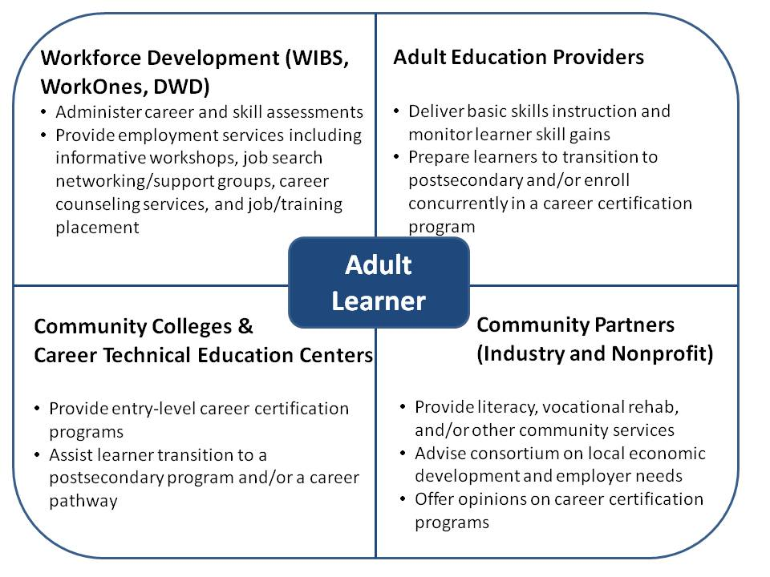

In PY 2014, IDWD continued to support the regional Consortium Model through continuation of grant dollars. During this reporting period, there were 27 ABE grantees, 7 ESL grantees with 11 non-school corporation fiscal agents. Each region’s Consortium worked collaboratively to update their original grant applications. Encouraging members of the complex workforce development system to partner with members of an equally complex adult education system can sometimes be challenging, even when adult education is housed at an agency focused on workforce development. Nonetheless, IDWD has continued to see great progress and many deliberate approaches to collaboration as a result of the regional consortium model. Some of the continued approaches include:

- Adult Education classes being held in more WorkOnes around the state
- WorkOne offices are co-located with Adult Education programs in some areas around the state
- Training staff and developing solid referral processes to ensure students get the services they need
- Implementing Indiana Career Explorer (career interest exploration system) and Career Connect (job matching system) into classroom lessons
- WorkOne staff coming to adult education orientations to give presentations on services available.
- Meeting regularly has increased and focused communication on common metrics, creating cohesive approaches to joint opportunities (i.e., ABE/EL/Civics, WIA incentive grant applications), leveraging respective spheres of influence to create career pathways and better serve students

Workforce Investment Board Involvement
IDWD continues to integrate Adult Education at the state and local level Workforce Development Boards. A representative from a local adult education program actively participates on the State Workforce Innovation Council (State Workforce Investment Board). In addition, just as representatives from the WDB staff participate in the adult education consortium, each of the twelve Local Workforce Development Boards has an Adult Education Representative as well.

Collaborations with IDWD Youth Initiatives
Since 43% of students enrolled meet the WIOA Youth definition, IDWD has continued to focus attention on bringing the Adult Education and Youth Initiatives (YI) Teams’ together to identify shared goals and team build. Teams comprised from both the AE Directors and YI Coordinators spent time with local AE programs to strategize on how the local and state programs can collaborate to achieve shared goals. Additionally, in PY14 the focus of the annual fall teacher meeting was the Search Institute’s 40 Developmental Assets for youth. The content of this meeting was developed per recommendations of YI Team partners to assist AE providers in serving youth under WIOA. Similarly, the YI annually presents on topics relevant to our shared work at the annual IN AE Summer Institute. Additionally, these two teams have worked closely to educate YI Coordinators on the WorkINdiana program, enrolling 78 youth this program year. The AE and YI Teams collaborated on a grant opportunity to provide work and learn opportunities to JAG participants and paid work experiences to WorkINdiana students.

Collaborations with Vocational Rehabilitation
IDWD and State Leadership from Vocational Rehabilitation meet regularly to align services. The partnership specifically with AE has included cross trainings between Adult Education Coordinators and Vocational Rehabilitation Regional Managers at the state level. At the local level, Vocational Rehabilitation representatives are invited to and actively participate at the Regional AE Consortia’s. Shared referral processes have also been developed in some regions.

WorkINdiana
WorkINdiana is a short-term training program designed to give adult education students access to occupational skills training and an industry recognized certification. This state-funded program requires collaboration between Career training providers, One Stop Centers and Adult Education Programs as students must be co-enrolled in WIOA Title I and Title II. Students may select certification training for one of 26 entry-level occupations in seven growing industry sectors. There were more than 400 career certification programs located in 84 cities by the end of June 2015.
The goals for PY14 were to increase quality enrollments, the number of training providers, and the number of entry-level industry-recognized certifications.

WorkINdiana PY 2014 Outcomes
Region | Enrolled | Still Enrolled | Completed | Completion Rate¹ | Certified | Certification Rate²
1 | 46 | 15 | 29 | 94% | 16 | 55%
2 | 85 | 10 | 64 | 85% | 33 | 52%
3 | 89 | 4 | 71 | 84% | 47 | 66%
4 | 95 | 9 | 73 | 85% | 44 | 60%
5 | 113 | 13 | 87 | 87% | 49 | 56%
6 | 45 | 3 | 37 | 88% | 34 | 92%
7 | 89 | 12 | 75 | 97% | 42 | 56%
8 | 50 | 8 | 38 | 90% | 26 | 68%
9 | 153 | 13 | 122 | 87% | 98 | 80%
10 | 6 | 0 | 6 | 100% | 6 | 100%
11 | 22 | 0 | 20 | 91% | 17 | 85%
12 | 105 | 18 | 77 | 89% | 36 | 47%
DOC | 203 | 10 | 178 | 92% | 178 | 100%
Total | 1101 | 115 | 877 | 89% | 626 | 71%

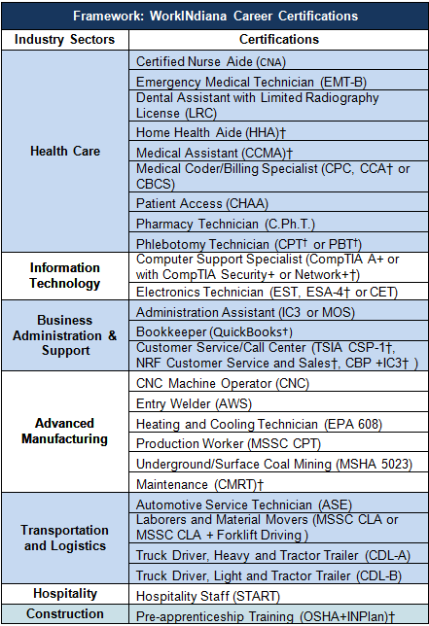

English Literacy/Civics (EL/C) Program;
Describe the activities and services supported with EL/C funds, including the number of programs receiving EL/C grants and an estimate of the number of adult learners served. (Only states receiving EL/C funds should respond to question #4).

In PY 2014, there were seven EL/Civics grant recipients. EL/Civics funds were used to support the development and delivery of the ESL-4-ESL training, described above, as well as workshops at the 2014 Summer Institute conference addressing the need of English Language Acquisition instructional staff. During this reporting period IDWD also applied for and was awarded OCTAE’s English as a Second Language Professional project (ESLPro) technical assistance. Through this technical assistance IDWD will focus on integrating work and career pathways into English Language Acquisition instruction, with the goals of:
- Creating a group of ELA Ambassadors made up of local program staff to assist in promoting and or delivering the ESLPro resources and trainings. This will be achieved through a train-the-trainer approach.
- Cross training AE and Workforce Development staff on how to support ELLs during transitions.
- Developing a quick-guide for occupational skills training instructors on how to support ELLs through technical training, with special emphasis on those trainings approved under IDWD’s WorkINdiana bridge program.
- Increasing ELL participation in IDWD’s WorkINdiana bridge program.

Secondary School Credentials and Equivalencies:
Describe your state’s policies related to how it awards a secondary school diploma or its equivalent to individuals who are no longer enrolled or required to be enrolled in secondary school under State law. Include state recognized tests that are used to award the diploma as well as other criteria that may be recognized, such as competency-based or credit-based methods.

As cited in IDWD Policy 2014-2 (http://www.in.gov/dwd/files/Policy_2014-02_HSE_FINAL.pdf), the IDWD, Division of Adult Education has the authority to grant the Indiana High School Equivalency (HSE) Diploma according to IC22-4.1-18 and to determine the assessment used to measure High School Equivalency. IDWD does not have any other criteria, competency-based or credit-based methods outside of the HSE to award a secondary school diploma or its equivalent to individuals who are no longer enrolled in secondary school.

IDWD has determined that CTB/McGraw-Hill’s Test Assessing Secondary Completion (TASC) is the sole assessment that shall be used to determine a testing candidate’s achievement of high school equivalency and thus eligibility to receive the Indiana HSE Diploma. Only testing centers that hold a testing center agreement with CTB/McGraw-Hill may offer the TASC test. It is understood that Data Recognition Corporation will acquire CTB/McGraw-Hill on July 1st, 2015, and that there will be no changes in services or interruptions in testing. The TASC may be administered in Indiana only to individuals who meet the following minimum guidelines:
- Does not hold a diploma from an accredited high school or its equivalent; and
- Is a resident of the state of Indiana for a minimum of thirty (30) days immediately preceding the day of testing; and
- Either
  - Has officially exited high school following the Indiana Department of Education (DOE) attendance requirements, using the official DOE exit form (attached), and obtaining a Superintendent’s signature using either the DOE exit form or the official DWD form (attached); or
  - Is at least eighteen (18) years of age;
- No individual under the age of 16 may sit for the high school equivalency test.
IDWD Policy 2014-02: High School Equivalency Testing also addresses and gives guidance on the following topics: testing registration and scheduling; accommodations; testing fees; proof of identity of test takers; minimum passing scores, testing time limits, retesting, cancellations, pre-existing test scores, portability and reciprocity of diploma.

Adult Education Standards:
Describe your state’s progress toward implementation of adult education college and career readiness (CCR) standards, including whether your state has formally adopted a validated set of CCR standards. Describe how the state has determined the standards to be representative of CCR and the timeline by which such standards will be or have been implemented by all local programs. Describe how the state is supporting the use of standards by local programs and State Leadership funds that are being used to support implementation.

As stated above, Indiana has adopted the TASC test, which is aligned with OCTAE’s College and Career Readiness (CCR) Standards for Adult Education. In addition, Indiana’s existing PD requirement that all instructional personnel who teach nine (9) or more hours must attend one IDWD-sponsored professional development event has allowed the state to quickly reach large numbers of teachers with Standards In Action training. The PD calendar of events moving forward will narrow to focus in-person training efforts on College and Career Readiness Standards (CCRS) implementation.

The Standards In Action (SIA) trainings are a series of in person and online trainings that dig deep into standards-based instructional practices for implementing the CCRS in Adult education classrooms. IDWD continues to use OCTAE’s SIA and Handbook for Sustaining Standards-based Education in Adult Education resources to improve the quality and reach of CCRS PD initiatives.

Below are descriptions of national, state, and regional professional development initiatives that support Indiana’s standards implementation efforts;

ANI & (AR)^2: IDWD continues to offer the ANI training using local program instructional staff as lead trainers. Additions of webinars, peer observations, conference calls, and online discussion boards have allowed IDWD to incorporate more of the CCR standards Key Shifts and Mathematical Practices into our ANI training. During the reporting period, IDWD, in partnership with TERC, delivered a follow-up training to ANI entitled Adults Reaching Algebra Readiness, or (AR)^2. (AR)^2 was delivered in a similar fashion to ANI, explicitly incorporating CCR standards Key Shifts and Mathematical Practices but focusing primarily on Algebra standards from the CCR.

SIA: Indiana attempted a small pilot of SIA Innovations 1 & 2 with a work group of instructors and administrators throughout 2013. Because most participants had never worked with standards, alignment processes, or curriculum mapping before, they struggled both with buy-in and completing the activities. IDWD used these struggles and participant feedback to inform PD offered to the entire field in 2013 (see descriptions below). IDWD partnered with LINCS to offer SIA training to a cohort of early adopter programs from across the state in the spring of 2014. During the reporting period IDWD re-ran a modified version of the SIA training, with two additional cohorts of programs, one in the north and one in the south. IDWD will continue to modify and deliver SIA training in subsequent years, and is currently building a resources warehouse of CCRS aligned materials within the state’s distance learning PD platform, Blackboard.

ESL-4-ESL: IDWD worked with subject matter experts to develop and deliver a 9-month-long extended learning cohort focused on Second Language Acquisition and ESL Teaching, Brain-Based Learning (BBL), Project Based Learning (PBL) Principles, and Technology Integration which includes explicit instruction on CCR standards relevant to work English Language Learners. The training also discusses and models instructional techniques using the Key Instructional Shifts from the CCRS. ESL-4-ESL included 3 face-to-face training sessions (2 days per session) and 4 live webinars. In addition, participants were required to implement strategies and tools in their classrooms as well as complete a variety of assignments via an online community of practice in between in-person trainings.

TASC Resources: To support the on-going goal of focusing on student transitions into post-secondary training and employment opportunities, IDWD continues our work with our HSE assessment vendor to provide resources demonstrating alignment between the HSE assessment and the CCR standards.

IN Teacher Competencies & Induction Project: Throughout 2014 IDWD convened a workgroup of diverse local program AE staff to conduct research on and develop a set of IN AE teacher competencies. This resulted in a set of draft competencies which included benchmarks and performance indicators placing a heavy emphasis on understanding and using the CCRS in instruction, performance monitoring, and staff development.

Another opportunity for CCRS implementation exists in the current AE priorities concerning student transitions and anticipated requirements under WIOA.

State transition goals include:
- By PY15 all local programs will be required to identify transition staff and hours allocated to transitions implementation.
- By PY15 all local programs will be required to offer employability/work ethics training as part of adult education curriculum.
- By May 2016 IDWD will complete Moving Pathways Forward pilot project..
- By PY16 50% of students with a traditional HS diploma or HSE diploma earners will enter a post-secondary training program.
- Support IDWD Youth staff in serving more out-of-school youth
- Align adult education content standards to the Indiana Academic Standards per WIOA regulations.

Conclusion
Indiana’s adult education system continues to make great strides, after multiple years of much change and transition. Indiana continues to refine the performance-based funding model to help support programs to focus on serving adult learners in a high-quality and efficient manner, with an increased emphasis on learner engagement, completion, and transition to postsecondary or career.

The continued investment of state leadership dollars into a robust system of professional development led to a series of events that engaged the majority of the practitioner population. As detailed above, IDWD continues to focus professional development opportunities on College and Career Readiness and the development of materials hosted on AmplifyAE.org.

IDWD launched the WorkINdiana occupational certification program in PY 2011. This statewide training program is only available to adult education students and is an excellent way to help them achieve the entry-level credentials they need to enter a career pathway in a promising industry sector in Indiana. The PY 2013 outcomes, such as 79% of students who enroll go on to earn a certification, support the growth and success of this program.

In the coming year, IDWD will continue to focus on supporting Adult Education programs making yet another shift to prioritize looking beyond the HSE, helping students make successful transitions to postsecondary training or employment utilizing career pathways.

