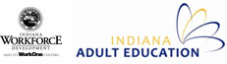
Indiana Narrative Report 2013-14
In Program Year 2013-14 (PY 2013), the Indiana Department of Workforce Development (IDWD) focused on raising the rigor within Adult Education. This was accomplished through adopting and providing education and support for a new High School Equivalency Test, developing standards-based education through the standards-in-action process, supporting transition to college or career through the WorkINdiana program and integration of career strategies in the classroom. IDWD continues to drive toward increasing enrollments, outcomes and partnerships. Additionally, IDWD continues to focus on innovative models of instruction and effective professional development to drive the system toward its vision of adult education programming that leads to successful career pathways, postsecondary transitions, and employment.

State Leadership Funds:
Describe the major activities supported with State Leadership funds during the reporting period and the extent to which these activities helped you in implementing the goals of the State plan. Specifically describe activities related to the implementation of career pathways.

DWD continues to offer an aggressive professional development schedule of programs in response to the gaps identified by an intensive needs survey and evaluation conducted during PY 2011. State leadership funds supported the following successful programs and activities:
- 2013 Summer Institute – IDWD hosted a 3-day event, with several tracks to support the various topics within the Adult Education field, e.g., English as a Second Language, College and Career Readiness, High School Equivalency Assessment. This event focused on the newly released College and Career Readiness Standards and the increased rigor of the high school equivalency assessment.
- Administrator meetings –IDWD provided additional administrator meetings this reporting period that covered the following topics: adult education policy and programs; high school equivalency testing, transitions, professional development, WorkINdiana and on-going implementing of IDWD’s Adult Education strategic vision.
- Adult Numeracy Institute (ANI) – See below Adult Education Standards section.
- Workgroups – IDWD continuously seeks feedback and collaboration form Adult Education administrators and teachers in building topics and content for Professional Development events and activities. IDWD continues to host workgroups to assist in the development and delivery of future professional development in Indiana. The names of the workgroups are: Standards in Action, Administrator Advisory Group, and Professional Development Advisory group.
- AmplifyAE – DWD continues to utilize and upgrade the AmplifyAE.org website, which houses all of the materials developed for professional development events as well as additional resources. This reporting year focused on adding the ability to register for events through this website.
- Fall Teacher Meeting – See below Adult Education Standards section.
- Standards In Action (SIA) - See below Adult Education Standards section.
- Annual Directors Meeting – IDWD offered this annual event that focused on the key shifts in instruction demanded by the College and Career Readiness Standards.
- External PD Opportunities – In efforts to encourage participation of Indiana Adult Education professionals in the national conversation regarding best practices for Adult Learners, IDWD offered 24 scholarships to the National Commission on Adult Basic Education (COABE) conference.
- Regional WorkINdiana Training for Adult Education & WorkOne Staff – IDWD offered several regionally based training over a span of 7 months focusing on best practices, the roles of Adult Education and the Workforce Investment System in supporting Adult Career Pathways and local planning on how to best offer the WorkINdiana program across the state.
- LINCS Math Tour – IDWD partnered with LINCS to offer a traveling 3-hour Numeracy Workshop at various locations across the state. Workshops focused on tools for engaging learners in meaningful math and explored hands-on strategies to help student develop reasoning and problem solving skills by increasing their ability to apply math content in a variety of real-life contexts.
- LINCS Online Course: Integrating Career Awareness – IDWD partnered with LINC to offer a six-week, online course to prepare instructors to implement the Integrating Career Awareness into the ABE & ESOL Classroom Curriculum Guide.
- Administrator 500 Leadership Series – IDWD continues to offer this year-long professional development initiative that focuses on innovative leadership to positively impact program outcomes.

IDWD continues to invest heavily in building the adult education professional development system. The above activities directly tie to the overall vision of ensuring that adult education students have the opportunity to earn both a high school equivalency diploma and an occupational credential that leads to high-value career opportunities. In total, roughly 540 Indiana adult education practitioners (directors, teachers, paraprofessionals, counselors, and volunteers) participated in at least one professional development meeting, which equates to roughly 77% of the total population (based on NRS Table 7).

Performance Data Analyses:
Describe any significant findings from the evaluation of your performance data for the reporting period and efforts to improve outcomes for the core indicators of performance.

PY 2013 Performance Outcomes
29,738 | - Student Enrollments  - 2% decrease over PY 12
22,729 | - Level Gains (student may have achieved more than one gain)  - 4% increase over PY 12
6759 | - HSE’s and HS Diplomas Awarded  - 8% decrease over PY 12
$1522 | - 14,335 students earned at least one level gain  - Cost per student who attained a level gain (equivalent to two K-12 grade levels)
1089 | - WorkINdiana Enrollments  - 69% increase over PY12  - 85% completion rate  - Of those who completed, 78% earned certification

DWD has a system of state performance metrics in addition to the federal measures required under the National Reporting System. Above is a summary of outcomes that state staff shares broadly with practitioners in the field. PY13 saw a decrease in enrollments. There could be many reasons for this decrease: residual effects of major change within the last two years; an inflated increase of enrollments last program year due to the planned transition to a new High School Equivalency Test, improved job opportunities not requiring HSD or HSE. IDWD will look at this data in depth to explore for trends that might provide a better understanding of the decrease. In addition, regions will be engaged in discussions regarding planning for increased efforts in recruitment and engagement, i.e., offering classes on site for employers or at nontraditional times and expanding distance learning. In addition, IDWD will pursue a marketing plan that focuses on recruitment and providing information about adult education to the general public, targeting this message to places where potential students might frequent, such as libraries and WorkOne Centers.

There was an 8% decrease of High School and HSE Diploma’s awarded. This decrease could be credited to the inflated number of test takers last reporting period, the last year to take the GED in Indiana. National conversation of TASC passing scores as compared to passing scores of other HSE tests were spurred this reporting year. Indiana engaged in conversation with CTB/McGraw Hill about passing rates and cut scores. This conversation will continue into the next reporting year.

NRS Table Highlights
Table 4
Indiana improved performance in all ABE categories, except ASE High. There could be two contributing factors for the decrease in this area: increased rigor on the High School Equivalency test and increased enrollments of students in an AE program who have already obtained their high school diploma although still need some remediation to be college ready. Indiana will continue to explore this data to determine what support is needed at the local programmatic level.

Indiana met and exceeded all proposed performance targets for ABE categories, except ASE Low. It is believed this is due to students existing programs to take the High School Equivalency prior to post testing. IDWD will continue to express the important of post-testing of all students.

While Indiana met two (ESL Low Beginning and ESL Low Intermediate) of the six targets for ESL, performance on all measures decreased. Each measure fell only slightly except for ESL Advanced. ESL Advanced saw a drop from 25% last reporting period to 10% this reporting period. It is also important to note that this category has the smallest number of enrollment of all the ESL EFL’s at 110 students compared to 409 to 1579. While the drop for ESL Advanced is significant, the 110 is only 2.5% of our total ESL enrollments. IDWD is developing a plan to explore this data at a deeper level to gain a better understanding of what is occurring at the program level.

Table 5
Obtained a GED or HS Diploma
The results of the Core Follow-up Outcome Achievement table for PY2013 are overall positive. Indiana surpassed its HS Diploma/GED target of 84% by achieving a result of 87% on that particular outcome. Indiana credits its field of practitioners with responding well to the performance incentive schedule, which incentivizes programs to move students through a quality curriculum as quickly as possible to help them to achieve their educational goals. While Indiana saw an 8% decrease in the number of HS Diplomas/GEDs awarded in PY 2013 over PY 2012, level gains increased by 4%.

Entered and Retained Employment
Indiana’s results in the Retained Employment category of 62% are much higher than its target of 44%. Indiana’s also met its target of 42% for the Entered Employment category.

DWD has placed a great emphasis on encouraging the adult education community to become a high-performing system that is focused on student outcomes, which of course includes transitions to career. In fact, the regional consortium model engages one-stop centers in the adult education process much more holistically, and improving employment outcomes remains mission critical. This collaboration appears to be benefiting students.

Entered Postsecondary
While IDWD did not meet the target, of 30% for Entered Postsecondary category, again this year, great strides have been made in this area. Indiana saw 27% of this reporting period’s population enter postsecondary. This is a significant improvement over the 19% reported for this category last reporting period.

Integration with Other Programs:
Describe how you have integrated activities funded under the Adult Education and Family Literacy Act (AEFLA) with other adult education, career development, and employment and training activities. Describe your efforts to develop or advance career pathway systems that include career and technical education, postsecondary education, employers, and economic and workforce development. Include a description of how your agency is being represented on the State and Local Workforce Investment Boards, the provision of core and other services through the One-Stop system and an estimate of the AEFLA funds being used to support activities and services through the One-Stop delivery system.

The IDWD to ensure Adult Education activities continue to be integrated throughout the state utilizing various methods. More specifically, through Indiana’s Regional Consortium Model, Involvement with the Workforce Investment Boards, Collaborations with Youth Initiatives at the state and local levels, WorkIndiaina programming and through the Moving Pathways Forward project.

Regional Consortium Model through Grant Competition
Beginning in PY 2011, the new grant competition allowed providers other than school corporations to act as fiscal agents responsible for the management of both federal and state funding streams. Previously, state funding had only been available to school corporations. The grant competition also called on consortium partners to launch WorkINdiana occupational certification program based on a statewide certification framework developed by DWD. In PY 2012, DWD refined the grant competition again by adding a performance element to the funding formula. Other new requirements of the refined grant competition asked providers to develop a more holistic plan around consortium management, WorkINdiana program development, learner engagement and completion, and college and career readiness.

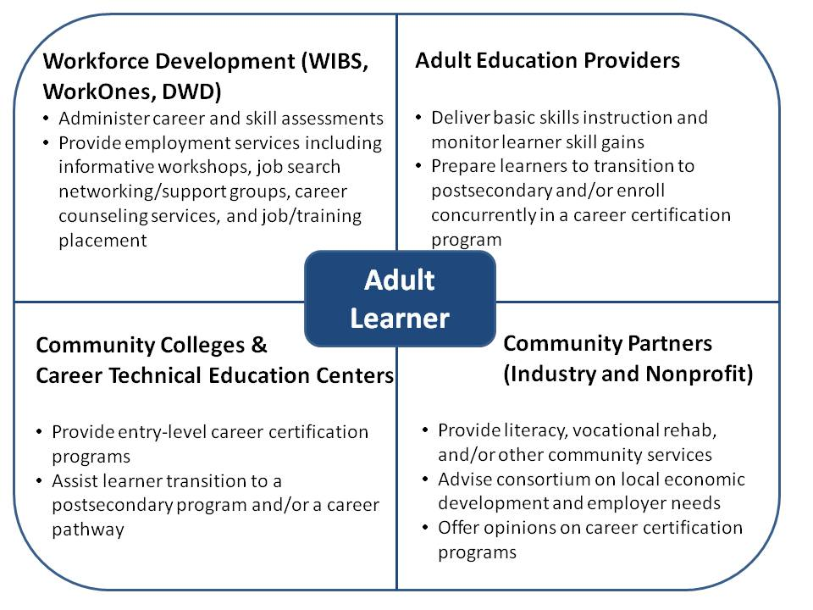

In PY 2013, IDWD continued to support the regional Consortium Model through continuation of grant dollars. During this reporting period, there were 27 ABE grantees, 7 ESL grantees with 8 non-school corporation fiscal agents. Each region’s Consortium worked collaborative to update their original grant applications. Encouraging members of the complex workforce development system to partner with members of an equally complex adult education system can sometimes be challenging, even when adult education is housed at an agency focused on workforce development. Nonetheless, IDWD has continued to see great progress and many deliberate approaches to collaboration as a result of the regional consortium model. Some of the continued approaches include:
- Adult Education classes being held in more WorkOnes around the state
- WorkOne offices are co-located with Adult Education programs in some areas around the state
- Training staff and developing solid referral processes to ensure students get the services they need
- Implementing Indiana Career Explorer (career interest exploration system) and Career Connect (job matching system) into classroom lessons
- WorkOne staff coming to adult education orientations to give presentations on services available.
- Meeting regularly has increased and focused communication on common metrics, creating cohesive approaches to joint opportunities (i.e., ABE/EL/Civics, WIOA incentive grant applications), leveraging respective spheres of influence to create career pathways and better serve students

Workforce Investment Board Involvement
IDWD continues to integrate Adult Education at the state and local level Workforce Investment Boards. A representative from a local adult education program actively participates on the State Workforce Innovation Council (State Workforce Investment Board) as well as on the Educational Review Committee, which is the subcommittee tasked with oversight of Adult Education and related activities. In addition, just as representatives from the WIB staff participate in the adult education consortium, each of the twelve Local Workforce Investment Boards has an Adult Education Representative as well.

Collaborations with IDWD Youth Initiatives
IDWD has focused attention on bringing the Adult Education and Youth Initiatives Teams’ together to identify shared goals and team build. Teams comprised from both the Adult Education Directors and Youth Initiatives Coordinators spent time with local AE programs to strategize how the local and state programs can collaborate to achieve the goal set by the Indiana Career Council of 60% of Indiana’s workforce will have the postsecondary knowledge, skills, and credentials demanded by Indiana’s economy.

WorkINdiana
In PY 2013, IDWD continued to focus on building WorkINdiana, Indiana’s occupational certification program that is funded through alternative funding streams and targets adult education students. Participants in WorkINdiana must be or have been enrolled in both WIA Title I and Title II programming. The goal is to enroll students in short-term training to earn an industry-recognized certification in a growing sector in Indiana.

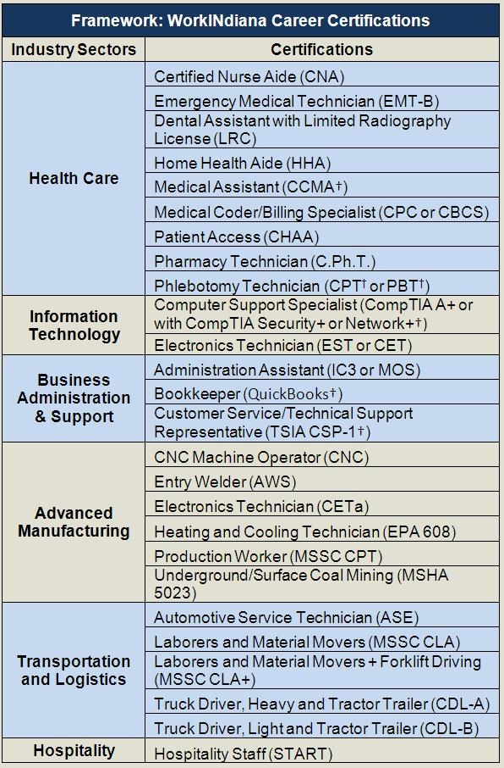
Professional development opportunities continued to be offered during this reporting year. Training events were held at local, regional, and state levels and sought to bring together one-stop partners and adult educators to encourage communication and collaboration between the entities around both WorkINdiana and other training and employment goals. In addition, IDWD continues to place special emphasis on collaboration between one-stop partners that serve out of school youth, as defined by WIA Title I, and adult education partners.

WorkINdiana PY 2013 Outcomes

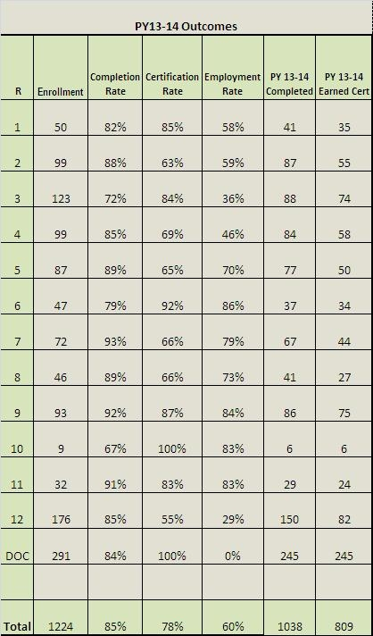

English Literacy/Civics (EL/C) Program;
Describe the activities and services supported with EL/C funds, including the number of programs receiving EL/C grants and an estimate of the number of adult learners served. (Only states receiving EL/C funds should respond to question #4).

In PY 2013, there were seven EL/Civics grant recipients who served 811 adult learners. These learners made 696 level gains in total (not per student). EL/Civics leadership funds were used to provide the ESL Institute, in which 68 instructors participated. The ESL Institute focused on using assessment, lesson planning and technology integration to increase speed and instructional effectiveness. IDWD also offered a daylong event for ESL Professionals, ESL Instruction in the 21st Century, that focused on the ongoing struggle between accelerating ESL learning and providing differentiation. National and local experts were brought together to provide skill based workshops on instructional strategies to improve differentiation and multi-level classroom instruction and curriculum mapping within ESL to create continuity between levels, maximizing instructional time by teaching in ‘chunks’.

Secondary School Credentials and Equivalencies:
Describe your state’s policies related to how it awards a secondary school diploma or its equivalent to individuals who are no longer enrolled or required to be enrolled in secondary school under State law. Include state recognized tests that are used to award the diploma as well as other criteria that may be recognized, such as competency-based or credit-based methods.

As cited in IDWD Policy 2014-2 (http://www.in.gov/dwd/files/Policy_2014-02_HSE_FINAL.pdf), the IDWD, Division of Adult Education has the authority to grant the Indiana High School Equivalency (HSE) Diploma according to IC22-4.1-18 and to determine the assessment used to measure High School Equivalency. Indiana does not have any other criteria, competency-based or credit-based methods outside of the HHSE to award a secondary school diploma or its equivalent to individuals who are no longer enrolled in secondary school.

IDWD has determined that CTB/McGraw-Hill’s Test Assessing Secondary Completion (TASC) is the sole assessment that shall be used to determine a testing candidate’s achievement of high school equivalency and thus eligibility to receive the Indiana HSE Diploma. Only testing centers that hold a testing center agreement with CBT/McGraw-Hill may offer the TASC test. The TASC may be administered in Indiana only to individuals who meet the following minimum guidelines:
- Does not hold a diploma from an accredited high school or its equivalent; and
- Is a resident of the state of Indiana for a minimum of thirty (30) days immediately preceding the day of testing; and
- Either
  - Has officially exited high school following the Indiana Department of Education (DOE) attendance requirements, using the official DOE exit form (attached), and obtaining a Superintendent’s signature using either the DOE exit form or the official DWD form (attached); or
  - Is at least eighteen (18) years of age;
- No individual under the age of 16 may sit for the high school equivalency test.
IDWD Policy 2014-02: High School Equivalency Testing also addresses and gives guidance on the following topics: testing registration and scheduling; accommodations; testing fees; proof of identity of test takers; minimum passing scores, testing time limits, retesting, cancellations, pre-existing test scores, portability and reciprocity of diploma.
Adult Education Standards:
Describe your state’s progress toward implementation of adult education college and career readiness (CCR) standards, including whether your state has formally adopted a validated set of CCR standards. Describe how the state has determined the standards to be representative of CCR and the timeline by which such standards will be or have been implemented by all local programs. Describe how the state is supporting the use of standards by local programs and State Leadership funds that are being used to support implementation.

As stated above, Indiana has adopted the TASC test, which is aligned with CRR standards. In addition, Indiana’s existing PD requirement that all instructional staff who teach 9 or more hours must attend one IDWD-sponsored professional development event has allowed the state to quickly reach large numbers of teachers with Standards In Action training. The PD calendar of events moving forward will narrow to focus in-person training efforts on College and Career Readiness Standards (CCRS) implementation. Tied to this requirement is funding in the form of allocations distributed out to regions and then to local programs specifically for PD.

The Standards In Action (SIA) trainings are a series of in person trainings that dig deep into standards-based instructional practices for implementing the CCRS in Adult education classrooms.

Below are descriptions of national/state/regional professional development initiatives that have supported Indiana’s standards implementation efforts;

ANI: Working with the Literacy Information and Communication System (LINCS), DWD continues to offer the ANI training with a cohort of 24 teachers (two from each of Indiana’s regions). DWD added additional requirements to ANI including four webinars and two separate peer observation sessions. The training explicitly incorporates the Mathematical Practices and Key Shifts. ANI will be offered a third time, to reach more teachers and train local staff to deliver the training. In addition AR^2 will be offered again through TERC to continue working with teachers who have completed ANI.

SIA: Indiana attempted a small pilot of SIA Innovations 1 & 2 with a work group of instructors and administrators throughout 2013. Because most participants had never worked with standards, alignment processes, or curriculum mapping before, they struggled both with buy-in and completing the activities. DWD used these struggles and participant feedback to inform PD offered to the entire field in 2013 (see descriptions below). This PD helped position the state in a place to be able to offer SIA statewide starting Spring of 2014 and continuing throughout the next program year.

Fall Teacher Meeting: The fall teacher meeting, Shifts Happen... And then we innovate!, focused on the key instructional shifts in the CCRS for Adult Education. This training emphasized the importance of focusing instruction on the standards rather than the more limited objectives of the HSE Test. Following this statewide event, lead teachers from across the state regionally delivered follow-up training on the standards in relation to the HSE Test.

TASC Trainings: To support the on-going goal of focusing on student transitions into post-secondary training and employment opportunities, DWD brought together a group of 24 teacher and administrators for a train-the-trainer aimed at exploring instructional strategies addressing both the HSE Test and the CCRS for Adult Education. These instructional leaders then delivered this training throughout the state in the fall of 2013.
NAEPDC NTI: DWD and EDSI, the professional development contractors, attended this institute to make key decisions about how and when to implement standards. Learning and conversations that occurred at this event convinced IDWD of the need for a fairly aggressive approach to implementation.

Another opportunity for CCRS implementation exists in the current AE priorities concerning student transitions and anticipated requirements under WIOA.

State transition goals include:
• By PY15 all local programs will be required to identify transition staff and hours allocated to transitions implementation.
• By PY15 all local programs will be required to offer soft skills/work ethics training as part of adult education curriculum.
• By May 2016 State agencies will complete Moving Pathways Forward project by May 2016.
• By PY16 50% of students with a traditional HS diploma or HSE diploma earners will enter a post secondary training program.
• Support DWD Youth staff in serving more out-of-school youth
• Align adult education content standards to the Indiana Academic Standards per WIOA regulations.

IDWD has dedicated the following resources to supporting the implementation of CCRS in local programs:
• 1, full-time staff person dedicated only to CCRS training
• 2 additional SIA training consultants
• 6 Regional Adult Education Coordinators to support communication & planning at the local level
• 25 teachers and administrators who have been through SIA training
• Mentor Exchange through Indiana Association of Adult Continuing Education (IAACE)
• Blackboard

CCRS Implementation Timeline:
PY14:
• ANI, (AR)2 & ESL-4-ESL (direct connections to CCRS)
• Integration of CCRS into Teacher Competencies/Induction Training & Tools
• SIA Early Majority cohort (Participant capacity: 70)
• January: Create PY15 PD calendar, write CCRS expectations & requirements in ABE grants, and revise PD policy

In PY15 we will re-run SIA with 5 trainers across the state to have half of all teachers initially trained in SIA. We will work with regional consortia to create flexibility within the existing training delivery model. We'll use Blackboard as our online standards-based education warehouse, and hope to engage instructional staff in contributing to and reviewing the resources housed here. Other efforts to follow-up with SIA graduates/programs will be explored in this year, including making connections to the teacher competencies and credentialing project. InPY16 we will re-run SIA with several pairs of teacher-trainers across the state and all teachers will be initially trained in SIA innovations.

Conclusion
Indiana’s adult education system continues to make great strides, after multiple years of much change and transition. Indiana continues to refine the performance-based funding model to help support programs to focus on serving adult learners in a high-quality and efficient manner, with an increased emphasis on learner engagement, completion, and transition to postsecondary or career.

The continued investment of state leadership dollars into a robust system of professional development led to a series of events that engaged the majority of the practitioner population. As detailed above, IDWD continues to focus professional development opportunities on College and Career Readiness and the development of materials hosted on AmplifyAE.org.

IDWD launched the WorkINdiana occupational certification program in PY 2011. This statewide training program is only available to adult education students and is an excellent way to help them achieve the entry-level credentials they need to enter a career pathway in a promising industry sector in Indiana. The PY 2013 outcomes, such as 78% of students who enroll go on to earn a certification, support the growth and success of this program.

Although Indiana has again experienced great change this reporting period, with the adaptation of a new High School Equivalency Test and focusing on implementing standards based education, students are progressing towards positive outcomes. In the coming year, IDWD will continue to focus on supporting Adult Education programs making yet another shift to prioritize looking beyond the HSE, helping students make successful transitions to postsecondary training or employment utilizing career pathways.

