2019-20 Narrative Report
Washington State
- State Leadership Funds (AEFLA Section 223)
- Describe how the State has used funds made available under section 223 (State Leadership activities) for each the following required activities:
  - Alignment of adult education and literacy activities with other one-stop required partners to implement the strategies in the Unified or Combined State Plan as described in section 223(1)(a).
In accordance with Section 223(1)(a) Washington State Basic Education for Adults (BEdA) and regional Workforce Development Councils (WDCs) developed a Shared Vision, Principles, and Goals of Collaboration Guidance document to guide alignment of adult education and literacy activities with the one-stops. This document continues to guide all MOU and IFA development, revision, and implementation across all 12 workforce regions.
In February 2017, the State Board for Community and Technical Colleges (SBCTC) met with all WDC directors across the state to clarify the roles and responsibilities of all partners in the review of Title II AEFLA grant applications and to train WDC directors and board leads on the feedback process. Feedback forms were developed and jointly agreed on and a conflict of interest agreement was completed for all reviewers. As a result, all Title II applications were approved for alignment with local industry sectors. Subsequent MOUs and collaborations continued throughout 2019-2020.
Throughout this last year, all programs continued to contribute Infrastructure Funding Agreements (IFAs) and established a Title II presence in WorkSource (one-stop) Centers across the state, prior to the closures due to COVID-19. SBCTC worked with Washington state’s Economic Development Department to provide initial WorkSource co-enrollment/proportional use data in support of state-wide IFA discussions and completions. Basic Education for Adults assigned a Policy Associate to provide technical assistance to all Title II providers around negotiations and implementation of the IFAs. While the pandemic closures complicated Washington’s cross-agency collaborations, the following are examples from the past year:
    - Workforce Central, the WDC in Pierce County, continued to fund a navigator position focused on recruitment of Title II students. While the navigator works at the locations of the 6 Title II providers in the county and the primary function is to recruit students for Title II programs, Workforce Central funds the position. This position is key to the county’s Power Up Pierce initiative that is connecting residents in the county with training and resources;
    - Everett Community College (EvCC), Edmonds Community College (EdCC), and Workforce Snohomish (local WDC) meet virtually to ensure goals and practices align to serve the Snohomish County community;
    - North Seattle College (NSC) leveraged existing relationships with its co-located one-stop on their campus to continue to provide WIOA co-enrollment and supports even as the campus was closed to all students, staff, and faculty.
    - The dean for Title II programs at Centralia College serves on the board of the Pacific Mountain Workforce Development Council to represent Title II providers; and,
State wide, Basic Education for Adults was highly engaged with all WIOA partners and stakeholders in the development and reauthorization of the WIOA Washington State Talent and Prosperity for All Plan (TAP). The focus of this collaboration is aimed at helping the state invest in activities and monitor progress on efforts to help more Washingtonians secure living-wage jobs that grow into lifelong career pathways while providing Washington industry with the skilled and educated workers they need to thrive. The work is guided by the following goals: Improving the Customer Experience, Engaging Business for Better Results, Accessibility and Technology, and Next Generation Performance Accountability. The Basic Education for Adults State Director and Policy Associates have been actively involved with every aspect of the revision of and the work to implement the state plan.
  - Establishment or operation of a high-quality professional development programs as described in section 223(1)(b).
The required and permissible activities under Section 223 State Leadership Activities Section 223(1)(B) and 231(b) emphasizes the importance of providing adult education and literacy activities, instruction incorporating the essential components of reading instruction, and disseminating information about models and promising practices related to the implementation of IET and IELCE programming and the improvement of instruction. Washington State implemented various professional development activities under Section 223 including:
SBCTC continues to prioritize and pioneer in the expansion of Guided Pathways for students enrolled in BEdA programs. Significant efforts have been made to integrate an understanding of guided pathways into most professional development offerings, as well as concepts related to diversity, equity, and inclusion, and the College and Career Readiness Standards (CCRS). Such elements are evident in system trainings such as New Teacher Orientation, CCRS-301, BEdA in Guided Pathways, and High School+: Forward Together. Moreover, these training opportunities spurred several communities of practice to provide additional exercises and support.
This year there were 37 trainings serving 1,395 participants funded by Leadership Block Grant dollars, including, but not limited to: What's Race Got to Do With It, BEdA to College, I-BEST Online, Reboot Your Classroom, Employability Skills, CASAS Cadre, NRS, New Teacher Orientation, BEdA in Guided Pathways, Intro to Culturally Responsive & Project Based Learning, High School+: Forward Together, Team Teaching and our in-demand training of Integrated Digital English Acceleration (I-DEA), and WABERS+.
COVID-19 had a profound impact on our approach to professional development, and yet only a few trainings were required to be cancelled outright. Our team was able to quickly assess the needs of the field and provide support, guidance, and opportunities for cross institutional collaboration as they transformed their courses to be taught online. We piloted our process in April 2020 with the 'Online I-BEST Support' webinar series that served 83 participants. Early and sustained success with online professional development created a foundation from which to grow, with SBCTC implementing opportunities and practices to expand online professional development opportunities and communities of practice for the foreseeable future.
  - Provision of technical assistance to funded eligible providers as described in section 223(1)(c).
- Data for Program Improvement (DPI) Trainings: Started system-wide DPI projects with all providers via online training. Providers discussed program issues around low performing educational functioning levels and placement. Programs used Tableau dashboards and system reports to access their data and create and share visuals. Those were used as the basis for evaluation plans to dive further into the issues. 76 people attended training.
- CASAS Trainings: Trained 110 people on WA State Assessment Policy, test record reporting requirements, and confirmed that staff in all funded programs have current CASAS training certification.
- NRS Trainings: Trained 83 directors, program coordinators, and data entry staff in key NRS data quality collection concepts. Converted training for new program directors into an online training that can run during suspended on-campus operations.
- WABERS+ Refresher provided quarterly trainings throughout the year that provided a review of WABERS+ and enhanced users understanding of WABERS+ procedures and policy updates. Trainings reviewed recent updates made to WABERS+ programming along with recent issues at the helpdesk. The trainings also reviewed data quality reports and post-test rates, end-of-year procedures, and WABERS+ programming changes for the next academic year, as well as carry-over procedures that can be used during summer and fall quarters.
- WABERS+ New User trainings that provided Data Access Users with 1 year or less experience using WABERS+ or users wanting to review the basics with instruction in all areas of data collection, reporting, and accuracy. The trainings reviewed access, user roles, Helpdesk roles, and data elements found in WABERS+. Instruction on how to run reports in WABERS+ and where resources could be found in WABERS+ and on the State Board website were also included in the training.
- On-going technical assistance to all programs through the WABERS+ helpdesk, over the phone and through WebEx sessions throughout the year.
  - Monitoring and evaluation of the quality and improvement of adult education activities as described in section 223(1)(d).
- On-site Program Review and Technical Assistance Visits were conducted by BEdA staff with 17 providers. Monitoring visits:
- 5 were follow up visits to check progress on Corrective Action Plans.
- Followed-up on newly established corrective actions.
- Conducted desk audits and follow-up visits with 5 providers to ensure issues were resolved and confirmed with evidence of corrected practice.
    - Scheduled revisits with 7 providers for continued monitoring of corrective action plans.
- As applicable, describe how the State has used funds for additional permissible activities described in section 223(a)(2).
Section 223(a)(2)(B) Instructional Technology
SBCTC continues to support the expansion of the Integrated Digital English Acceleration (I-DEA) program in Washington, and across the country. The I-DEA program administrator continues to offer training and technical assistance to those offering I-DEA on their campuses via WebEx, Canvas, and in-person. Additionally, all current and new I-DEA instructors had the opportunity to participate in two three-day web-based trainings on I-DEA in March and June 2020. An asynchronous I-DEA 101 training was also offered for both in-state and out of state faculty. To ensure that everyone has current and up to date information on I-DEA, BEdA maintains I-DEA pages on the SBCTC website.
SBCTC continues to support the use of technology in Washington Corrections Institutions. In 2020, a Canvas 99 training was developed and delivered to faculty teaching in WA correctional sites. This training offered specific information on the offline version of Canvas and the SMC tool that faculty would use to convert online curriculum into an offline format. Additionally, work on converting HS+ for use in the corrections has begun.
  - Section 223(a)(2)(D) Integrated Education and Training (IET) and Career Pathways
Washington state continues to expand I-BEST in tandem with the statewide Guided Pathways initiative, and we have developed a model that guides this work and fuels the increase of basic skills students placed on career pathways that lead to in-demand, living wage work. In a nutshell, Guided Pathways “presents courses in the context of highly structured, educationally coherent program maps that align with students’ goals for careers and further education” (“What We Know About Guided Pathways”; http://bit.ly/2qpJ51c). Colleges organize program offerings under different “meta majors” or areas of study connected to high demand, living wage jobs and transfer pathways. In the model that we have created to integrate basic skills into the Guided Pathways initiative, we work with providers to ensure that I-BEST is available in each meta major at the college, expanding both choice and support for basic skills students.
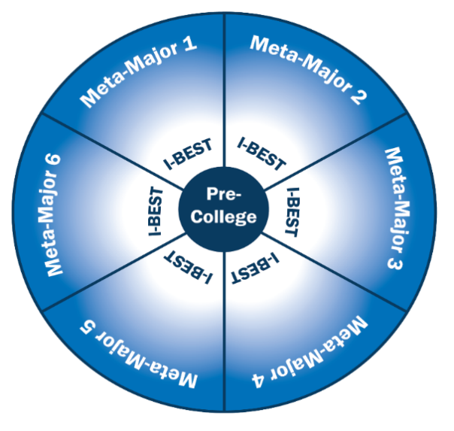
In this model, when a student tests into basic skills (“pre-college” in the visual representation of the model), they are assessed for skill levels, and whether or not a high school credential is needed. Goals, interests, and a meta-major (or broad industry sector or career pathway--like healthcare or business) are identified and a navigator assigned. Funding is then identified and an educational plan created. Earliest English language acquisition and basic skills learners are placed in foundational programming that contextualizes college and career readiness to the different meta-majors available at the college. Then, when students are ready, they move into the college-level certificate or degree program within that meta-major. I-BEST is offered as a core of each meta-major at this level, providing the added academic and navigational support students need to be successful. Students in need of a high school credential are co-enrolled for dual credit in High School +, or receive their high school diploma upon completion of their two-year degree.
In support of this work, our office offered multiple professional development and learning opportunities to providers as well as information sessions to disseminate the model and encourage its adoption. Furthermore, in the pandemic we continued this work by shifting to online professional learning. Offerings included:
- We converted our planned IET conference “strand” (10.5 hours of content normally delivered over three days f2f) into an online team teacher training course that will eventually feed into a community of practice in 2021.
- We conducted an “Online I-BEST Web Series,” a six-week series of weekly meetings centered around multiple topics related to offering I-BEST – an IET model that features team-teaching – in an online environment. The web series is available online. Topics included:
  - The six team teaching models online
  - Using zoom for instruction
  - Asynchronous v synchronous sessions
  - Distance ed requirements and I-BEST
  - Collaborative planning online
- Connected to our IET/Pathways work is our expansion of Ability to Benefit with ED approval of our state-defined process.
  - Section 223(a)(2)(F) Transitioning to postsecondary
High School+ (HS+) is a competency based high school completion program and part of our college and career guided pathways initiative which allows students to obtain a high school diploma and then transition into postsecondary education. This program has also expanded to act as a dual credit program for students without a high school diploma enrolled in college-level pathways. To support the further implementation and expansion of HS+, SBCTC conducted local trainings and technical assistance with Deans/Directors, registrars, navigators, advisors, etc. We also conducted a virtual State-wide event for providers around best practices and the culturally responsive and inclusive revision of a state sponsored curriculum. During the 2019-20 Program Year HS+ enrolled 3,935 students and awarded 905 high school diplomas, which due to COVID-19 represented a significant decrease from 2018-19. More colleges followed the lead of Shoreline Community College and Whatcom Community College and completed crosswalks between the requirements of select I-BEST programs to the Washington State High School Graduation Requirements. This work allowed the navigators at more institutions to advise students on how to meet their high school requirements through the courses in their I-BEST program.
  - Section 223(a)(2)(G) Literacy and English Language links to employers
Integrated Digital English Acquisition (I-DEA) classes teach soft skills along with math and English in all modules. In addition, students complete four modules on Personal Inventory, Career Exploration, Work Readiness, and Job Search and Interviewing that focus specifically on employment and employability skills. I-DEA is delivered in the flipped classroom model incorporating intensive digital literacy outcomes and requiring students to critically think and solve problems in technologically rich environments.
  - Section 223(a)(2)(H) Workplace adult education
SBCTC is advancing the I-BEST @ Work model, which is an IET model that can meet IELCE standards and provides the opportunity to further WIOA Title II initiatives. This model includes a company trainer, adult basic education instructor and a navigator to provide wraparound support. The program is designed to quickly teach workers literacy, technology, work and college readiness skills so they can move into postsecondary education or living wage jobs faster. The pandemic posed a challenge for this model in that it was primarily based in on-site learning in industries that have been hit hardest by the pandemic: retail, hospitality, food service, and tourism. We remain committed to the model and plan to revitalize the model in 2021.
  - Section 223(a)(2)(I) CCRS
SBCTC Basic Education for Adults (BEdA) delivered two regional trainings and one virtual training on the CCRS with a focus on culturally responsive instruction and assessment through problem and project-based learning with the CCRS as the foundation of that instruction and assessment.
Rigorous monitoring ensured that all funded programs implemented professional development in support of full WIOA and CCRS implementation and that leadership funding, provided through their Leadership Block Grant supported educational practices in support of CCRS implementation.

Performance Data Analysis
Describe how the adult education program performed in the overall assessment of core programs based on the core indicators of performance. Discuss how the assessment was used to improve quality and effectiveness of the funded eligible providers and any plans to further increase performance in future reporting years.
Washington State achieved a 38% overall Measurable Skill Gain (MSG) rate for program year 2019-20, significantly lower than its MSG target of 47%. This is most likely due to statewide suspended operations caused by the COVID-19 pandemic.
It’s impossible to fully evaluate program effectiveness since all providers stopped conducting CASAS and GED® tests around March 2020 and remained shut down through the end of the program year. Our WA BEdA providers reported that 6,099 students could not be pre-tested and were enrolled using eligibility methods other than standardized assessments. Additionally, they reported that 11,073 students who were not post-tested due to COVID-19 shutdowns.
Table 4 shows a 12% drop in MSG from PY2018-19 to PY2019-20 (year-to-year). This table also shows a 9% increase in participants separating before achieving an MSG. Furthermore, this table shows a 22% increase for those who attained a secondary School diploma or its Recognized equivalent.
Table 4 shows that program participation (first period of participation only) also significantly decreased, from 43,160 to 37,995, about a 12% decrease compared to the previous year. Moreover, the percentage of students that exited the program and re-enrolled during the program year also decreased further reducing the overall Total Number of Periods of Participation.
Overall average attendance hours fell slightly from 115.1 to 114.4 which may be due the mid-winter quarter shift to all online classes. Undoubtedly some class time was lost in that transition. Then again, the same situation caused the average distance education hours increased meaningfully from 87.5 to 96.3 hours. Meanwhile the average attendance hours for students who pre- and post-tested increased by 7% showing that students were previously engaged in programs.
Further, Table 4a shows year-to-year drops in EFLs of 25% for Reading/Listening subjects and 3% for Math while increases in EFLs for earning credits (3%) and postsecondary enrollment (6%).
Also, Federal Table 4b shows a similar year-to-year EFL gain rate for those post-tested (about 56%) but a 14% drop in the number of those post-tested. The prior year’s post-test rate was about 60%. There were 8,369 fewer students who pre- and post-tested as compared to last year.
Table 4c shows distance education participation more doubled since the prior year. All providers were able to move coursework online for the remainder of the program year so this makes sense. Although, since they were not able to conduct CASAS tests, the MSG rate for distance education participants is significantly below prior years.
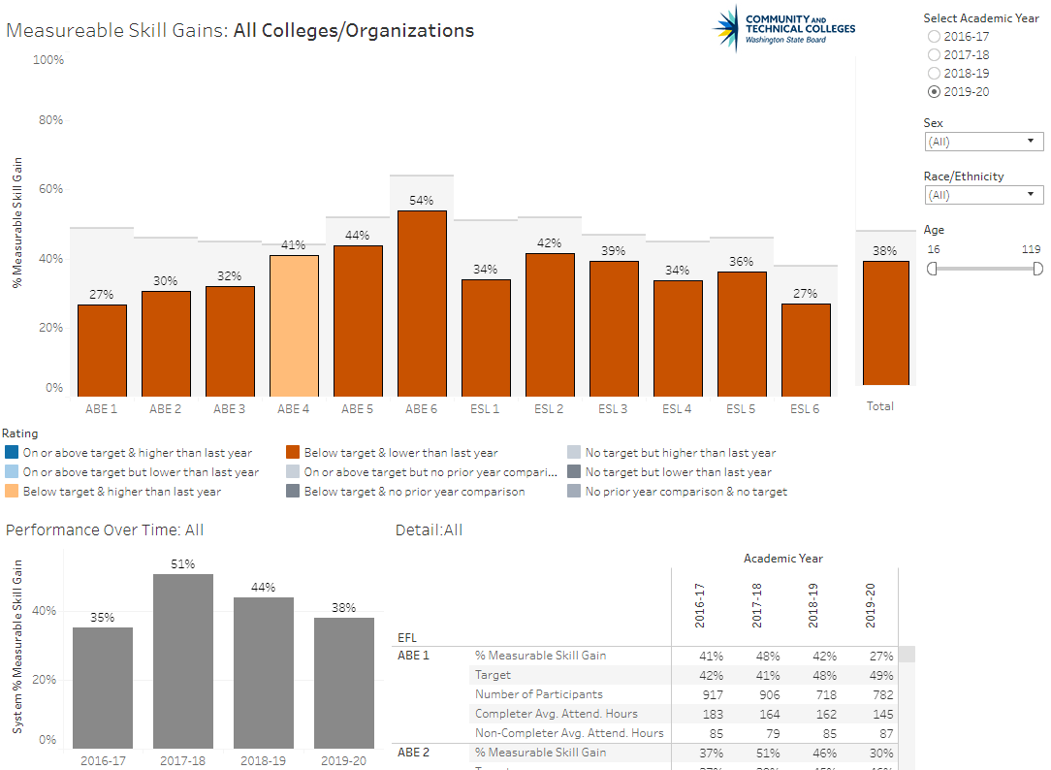
Lastly, a review of 2019-20 performance data (see image: Measurable Skill Gains Tableau dashboard) shows sustained performance at ABE 5 and ABE 6 levels. This is likely due to our state’s use of the HS Credit Option assessment method which does not rely on CASAS testing. Students are able to earn Measurable Skill Gains based on the awarding of required high school credits and earning their diploma.
Projection 1: Using Data On-hand
Out of our 38,738 participants (Table 4 column J), our WA BEdA providers reported that 11,073 students were not post-tested due to COVID-19 shutdowns.
Next, we can project EFL gains from testing using a few simple assumptions based on PY2018-19 federal table data. First, the average percent of students who took a post-test was 59.5% (25,689[Table 4b column B]/43,160[Table 4 column B]). Second, the average percent of students achieving an EFL gain (56.0% [Table 4b column G]).
So, given a participant count of 38,738 and projecting that we would have tested 59.5% of the 11,073 students who were not post-tested due to COVID-19 shutdowns were post-tested and 56% made an EFL gain, then we would have an additional 3,690 EFL gains to add to our performance on Table 4 column K. That would give us 16,161 EFL gains in column K representing pre-post-test gains, HS Credit Option EFL gains, and EFL gains from program exit and enrollment in postsecondary during the program year (already part of the count on Table 4 column K). Columns K and L combine to make 18,388 overall MSGs for a projected MSG rate of 47.47%.
Projection 2: Forecasting
Staff in the SBCTC Research department projected an enrollment decrease of 3.7% for PY2019-20 based on 8 years of prior enrollment data and forecasted our overall enrollment at 42,731. This forecast figure is the enrollment we would have expected if the pandemic hadn’t happened.
Next, we can project EFL gains from testing using a few simple assumptions based on PY2018-19 federal table data. First, the average percent of students who took a post-test was 59.5% (25,689[Table 4b column B]/43,160[Table 4 column B]). Second, the average percent of students achieving an EFL gain (56.0% [Table 4b column G]).
So, if 59.5% of the projected 42,731 students were post-tested and 56% made an EFL gain, then our Table 4b would have 14,238 EFL gains. Given that table only shows 9,614 EFL gains, we would need to add an additional 4,624 EFL gains to our performance on Table 4 column K. That would give us 17,095 EFL gains in column K representing pre-post-test gains, HS Credit Option EFL gains, and EFL gains from program exit and enrollment in postsecondary during the program year (already part of the count on Table 4 column K). Columns K and L combine to make 19,322 overall MSGs for a projected MSG rate of 45.22%.

Integration with One-stop Partners
Describe how the State eligible agency, as the entity responsible for meeting one-stop requirements under 34 CFR part 463, subpart J, carries out or delegates its required one-stop roles to eligible providers. Describe the applicable career services that are provided in the one-stop system. Describe how infrastructure costs are supported through State and local options.
In Washington, for each of the 12 local workforce development regions eligible providers were identified through the competitive RFA process. In 2019-20 providers included 34 community and technical colleges and six community-based organizations. These providers supported the local one-stops with a wide range of Title II programming and services in adult education, ELA, IET, and IELCE. All Title II provider continuations were approved for alignment with the local workforce plan by the local workforce board and detailed one-stop contributions. Contributions are detailed in a state-level Shared Vision, Principles, and Goals of Collaboration Guidance document developed by and signed by the Washington Workforce Association (WWA) and SBCTC. The collaboration document details the support services and programming that are jointly provided including: case management, pathway development, education opportunities, job placement, vocational rehab, etc. The scope of these programs is funded by both state and federal funding. Renton Technical College (RTC) continues to provide instruction at WorkSource Connection Sites (Seattle/King County Workforce Development Council), including RTC's main campus, King County Library System (KCLS), and Birch Creek Apartments (King County Housing Authority). Providing multiple, community-based locations with other co-located services is a key characteristic of the RTC College and Career Preparation (CCP) program. The Spokane College District participates in the Skilled Trades Preparation program with multiple WIOA partners. This program employs a shared WorkSource Navigator who recruits students to the program and provides employment placement upon completion. The four WIOA Title II providers in the Northwest Workforce Council (Bellingham Technical College, Community Action Skagit County, Northwest Indian College, and Whatcom Community College) formed the Basic Education for Adults Consortium and meet quarterly to align and coordinate services in their workforce development area.
- Integrated English Literacy and Civics Education (IELCE) Program (AEFLA Section 243)
Describe how the state is using funds under Section 243 to support the following activities under the IELCE program:
  - Describe when your State held a competition [the latest competition] for IELCE program funds and the number of grants awarded by your State to support IELCE programs.
In 2016-17 we held an open and competitive grant process; providers were required to outline their programming based on the new regulations in place for IELCE. Thirty-one grants were awarded in this process. We also updated our WABERS+ reporting system so that providers could better track who is being served by IELCE funds.
  - Describe your State efforts in meeting the requirement to provide IELCE services in combination with integrated education and training activities;
Washington state provides technical assistance opportunities for IELCE funded programs including:
- Advancing the I-BEST @ Work model as an ELL incumbent worker IET model that meets IELCE requirements;
- Providing on-going technical assistance via phone and email to support providers in meeting IELCE requirements;
- Providing technical assistance on the use of 243 funds to cover student tuition in an IET program; and,
- Monitoring programs to ensure allowable use of IELCE 243 funds and provided technical assistance in meeting corrective action plans.
  - Describe how the State is progressing towards program goals of preparing and placing IELCE program participants in unsubsidized employment in in-demand industries and occupations that lead to economic self-sufficiency as described in section 243(c)(1) and discuss any performance results, challenges, and lessons learned from implementing those program goals; and
Washington State has I-BEST/IET pathways in 33 of 34 community and technical colleges. Of these, over 250 approved pathways are suitable for IELCE program participants. I-BEST pathways are approved career technical and academic/transfer pathways that lead to industry-recognized certificates and degrees that lead to unsubsidized employment in in-demand industries and occupations that lead to economic self-sufficiency. Further, the I-BEST @ Work model works with entry-level incumbent worker ELLs to upskill so that they can move up in the company and access further education and training opportunities. In addition, SBCTC has supported the development of IELCE-funded navigators designed to provide wraparound support services to students in IELCE-funded programs. Challenges include continuing to support basic skills working with employers.
  - Describe how the State is progressing towards program goals of ensuring that IELCE program activities are integrated with the local workforce development system and its functions as described in section 243(c)(2) and discuss any performance results, challenges, and lessons learned from implementing those program goals.
In accordance with Section 223(1)(a) Washington State BEdA and regional WDCs developed a Shared Vision, Principles, and Goals of Collaboration Guidance document to guide alignment of adult education and literacy activities with the one-stops that guides collaboration and implementation.
Through I-BEST, English language learners in Washington State are in professional-technical programs that lead to living-wage work in high demand industries. I-BEST is included in Washington State’s Combined State Plan under WIOA, Talent and Prosperity for All and requires approved integrated outcomes and highly contextualized instruction.
I-BEST @ Work leverages local relationships with WDCs to assist with both employer partnerships and navigational services. Several providers are in dialogue with their WDCs about potential I-BEST @ Work programs.
Challenges include placing students in the earliest levels of ELA onto an occupationally specific career pathway and in connecting those early learning pathways directly to career pathways. In consultation with OCTAE, having a navigator position funded by IELCE has assisted with this challenge. Accessing financial aid for ELA students is also a major challenge to enrolling students into college-level programming.

Challenges include placing students in the earliest levels of ELA onto an occupationally specific career pathway and in connecting those early learning pathways directly to career pathways. In consultation with OCTAE, having a navigator position funded by IELCE has assisted with this challenge. Accessing financial aid for ELA students is also a major challenge to enrolling students into college-level programming. Adult Education Standards.
If your State has adopted new challenging K-12 standards under title I of the Elementary and Secondary Education Act of 1965, as amended, describe how your Adult Education content standards are aligned with those K-12 standards.
  - Optional – Describe implementation efforts, challenges, and any lessons learned.
Washington State’s K-12 system adopted the Common Core State Standards in 2011. To ensure Title II Adult Education alignment with K-12, Washington adopted the College and Career Readiness Standards (CCRS) (aligned to the Common Core) in fall of 2014.
Through a series of regional trainings in 2015, SBCTC helped provider faculty become familiar with the CCRS as they integrated these standards into their curriculum and instruction. All providers implemented the CCRS into their programs by July 1, 2016. Since 2016 SBCTC BEdA infused the CCRS into most professional development to establish the standards as the foundation of instruction and to demonstrate the clear applicability to student learning. This continued in 2019-20 through face-to-face and, due to the COVID-19 closures, virtual professional development for faculty, staff, and administrators.
- Programs for Corrections Education and the Education of Other Institutionalized Individuals (AEFLA Section 225)
What was the relative rate of recidivism for criminal offenders served? Please describe the methods and factors used in calculating the rate for this reporting period.
The current 2014-2016 recidivism rate (last three-year period available) is 33.5%.
For the 2019-20 program year, Washington State will use a three-year re-incarceration rate that is used by Washington Department of Corrections and county jails. The re-incarceration rate is calculated by dividing the number of participants who released in 2019-20 and returned to jail or prison by the total number of participants who released in 2019-20. Recidivism refers to a person's relapse into criminal behavior. It is measured by criminal acts that result in a return to a Department prison facility with or without a new sentence during a three-year period (36 months) after being released from prison. Results for the 2019-20 program year will be available in the 2021-2022program year.

